Website Handling Persons & What we used
HANDLING PERSONS DETAILS
S.NO | Role | Name | Working Hours
1 | Project Manager | - Christina  - Madhan
2 | Designers | - Sunil  - Dhinesh Anand  - Vignesh
3 | Developer | Frontend:  - Siva Shanmugam  Backend:  - Kavi Rajan  - Siva rex
4 | Testers | - Maniyarasan  - Vaishnavi
WHAT WE USED FOR THE WEBSITE:
- Developing:
Frontend: React and Next.js
Backend: Node.js, Express, MongoDB, and Mongos
- Valid SSL:
Issued On
Monday, August 25, 2025, at 5:25:54 PM
Expires On:
Sunday, November 23, 2025, at 5:25:53 PM

- Testing: What are we see
manual testing
1. Frontend:
1. Design Aspects Like logo, font size, color, spacing, image relevance… etc.
2. Content Checking
3. URL Checking
4. Responsiveness
5. Functionality for all forms with email template
6. SEO (As of now, we don't have)
2. Backend:
1. Dashboard
2. Admin Panel
DEVICE | RESOLUTIONS | BROWSERS | Tools
Desktop | 1. 1920  2. 2000  3. 1680  4. 1600  5. 1400  6. 1440  7. 1366  8. 1360  9. 1280  10. 1152 | - Chrome  - Firefox  - Safari | Note: All Res  1. Content Checking – Manual  2. Links—Any online tools and Manual  3. Functionality - Manual  4. Font size, color & spacing—What font tool and Visbug
IPAD & Tab | 1. 600 to 767  2. 768 to 800  3. 801 to 981  4. 982 to 1000  5. 1001 to 1100  6. Above 1101 to 1151 | - Chrome  - Firefox  - Safari
Mobile | 1. 350  2. 400  3. 430  4. 460  5. 460 to 599 | - Chrome  - Firefox  - Safari

Page Flows
Home Page
LUNCH BOWL DOCUMENTATION

Project Overview
Project Name: Lunch Bowl
Short Description:
Lunch Bowl is a website providing nutritious lunch delivery for school students (child to 12th grade). Deliveries are available Monday to Friday. Saturdays and holidays are paid separately, except in the subscription plan.
Client Preferences:
Pricing Plan: ₹200 per meal
Sunday: No deliveries
Note:
1. “Lunch is pure veg / Jain food.”
2. Eco-Friendly Packaging
- Material: Lunch Bowl does not use plastic boxes.
- Alternative: All lunch boxes are made from sugarcane-based biodegradable products.
- Purpose: Ensures sustainable, safe, and hygienic meal delivery for children.

Website Pages:
- Home Page
- Food Menu Page
- About Us Page
- Contact Us Page
- Pricing Plan Page
- Terms & Conditions Page
- Privacy Policy Page
- Refund Policy Page

Terms & Conditions (Short Overview)
Lunch Bowl offers a subscription-based, nutritious lunch delivery service for school children. Parents/guardians must provide accurate details, manage payments, and review dietary needs. Deliveries are made only to affiliated schools. Lunch Bowl is not liable for delays beyond its control. Services, pricing, and terms may change; continued use implies acceptance.

Privacy Policy (Short Overview)
We collect parent and child details to process orders and personalize meals. Your information is used only for deliveries, payments, and service updates and is never sold. Data is secured with reasonable safeguards and may be shared with trusted partners (delivery/payment providers). Users can access, correct, or delete data anytime via contactus@lunchbowl.co.in.

Refund Policy (Short Overview)
Cancellations must be submitted 48 hours in advance. Refunds are not issued, but cancelled orders are credited to the Lunch Bowl wallet for future use. Service disruptions due to uncontrollable events are not eligible for refunds.
***************************************************************************

Home Page Documentation

Website Header
- Login/Sign Up:Single popup for registration, payment, and login redirection
- Start Free Trial: Only for tie-up schools (no deliveries on Sundays). Free delivery requests handled via this form
- Navigation Menu: Home, About Us, Food Menu, Contact Us, Instagram, Facebook

1. Banner Section (Hero)
1.1 Left Side:
- Tagline and introduction content
- Note: “Lunch is pure veg/Jain food.”
- Button: Explore More → Should redirect to the Food Menu Page (Details: you can see the food menu page).
- Note: Refer to the Food Menu tab in this documentation for full food menu information.
1.2 Right Side:
- Embedded YouTube video showing the Lunch Bowl team preparing food.
- Action: Click → Opens pop-up model to play full video

2. About Us Intro Section
2.1 Left Side:
- A boy holding a lunchbox and food-packing image. (Lunch Bowl image provided by client)
2.2 Right Side:
- Mission statement and brief content
- Button: Read More → Redirects to About Us Page
Note: Refer to the About Us tab in this documentation for full About Lunch Bowl information.

3. Food Menu Section (Healthy Pack)
3.1 Heading & Tagline: Introduces the menu
3.2 Display:
- Shows 6 food items; other items will be seen in the food menu page.
- Button: Explore More → Redirects to Full Food Menu Page (30+ items)
Note: Refer to the Food Menu tab in this documentation for full food menu information.
3.3 Food Card Behavior (Popup):
- Each card displays the name, tagline, and plate image.
- Hover: Plate image changes to Lunch Box image
- Click Action (Popup Opens):
  - Left Side: Plate & Lunch Box images
  - Right Side: Name, Description, Ingredients List, Nutrition Values:
    - Calories
    - Carbohydrates
    - Proteins
    - Fats
    - Fibre

4. Serving Your School Section
4.1 User Options:
- Select a School from the dropdown → Check availability
  - Next Button: Appears if school is eligible → Opens Sign-Up & Payment Flow Finished → Shows menu calendar
  - Already registered → Next Button does not appear
- School Not Listed: User enters school name manually
4.2 Form Flow:
- Click Next Button → Opens form Popup Form
- Form Fields: Name, Email, Phone Number, School Name
- Submit Button: Redirects to Thank You Page

5. How It Works Section
- Shows a 4-step visual workflow:
  - Create Account
  - Choose Menu
  - Place Order
  - Sit Back & Relax (Meals Delivered)
- Informational only – no clickable buttons, but hasa navigation arrow.

6. Meet the Team Section
6.1 Homepage Display: Shows 4 chef profiles initially
6.2 Explore More / Scroll Arrow:
- Action: Click → Redirects to Team Page with all chef profiles. Note: Refer to the About us tab in this documentation for full Team information.
6.3 Chef Card Details:
- Image of a chef
- Name
- Short Description / Bio

7. Nutrition Section
7.1 First Free Session: Shows nutritionist image (image provided by client) + introduction
7.2 Button: Let’s Talk → Should Opens pop-up form
7.3 Form Fields:
- Name*
- Email*
- Phone*
- Optional Message
7.4 Submit Button: Redirects to Thank You Page

8. FAQ Section
- Contains 11 common queries
- Accordion layout for readability
- No buttons or redirects
Note: This FAQ Has Specific Pages only, Like Home, Contact us, Register page .

9. Call To Action (CTA) Section
9.1 Prompt Button Name: “Get in Touch”
9.2 Button: Should open pop-up form
- Fields: Name, Number, Email, Message
9.3 Submit Button: Redirects to Thank You Page

10. Footer Section
10.1 Links:
- Home → Home Section
- About Us → About Us Page
- Food Menu → Food Menu Page
- Contact Us → Contact Us Page
- Terms & Conditions → Terms & Conditions Page
- Privacy Policy → Privacy Policy Page
- Refund Policy → Refund Policy Page
10.2 Additional Elements:
- Social Media Icons (Instagram, Facebook) → Opens respective pages in a new tab.
- Copyright notice → Auto-update yearly (currently 2025)
- ODI Logo → Click → Redirects to ODI Website in a new tab.
*****************************************************************************
ABOUT US FLOW:
1. Banner Section
- Left Side:
  - Page Title (About Us)
  - Breadcrumb (Home > About Us)
  - Short tagline/intro line.
- Right Side:
  - Stock image (relevant to food/children/lunch box).
2. Intro Section
- Left Side: Introduction content about Lunch Bowl.
- Right Side (Two images):
  - Image 1: Boy holding lunchbox
  - Image 2: Mother and one girl image.
3. Mission Section
- Left Side: Mission-related image (children, eco-friendly lunch box, etc.)
- Right Side: Mission content (Lunch Bowl’s goals & purpose).
4. Team Section
- Grid of 5 team members.
- Each card shows a photo and name.
- On hover → additional info/content appears.
5. Video Section
- One embedded video about Lunch Bowl.
- When clicked → plays directly within the section (no external redirect).
6. How It Works Section
- Same content/flow as Homepage “How It Works” section.
- Explains process in simple steps with Image.
7. Our Environment Section
- Horizontally scrolling image gallery—Stock Image.
- Auto-play or manual scroll → shows environmental initiatives (eco-friendly packaging, zero plastic, etc.).
8. Call-to-Action (CTA) Section
- Styled and functionality are the same as Homepage CTA for consistency.
9. Global Footer
- Same across all pages.
- Footer links (About, Menu, Contact, Privacy, etc.)
- Social media links.
*****************************************************************************
FOOD MENU: PAGE FLOW
Food Page:
1. Banner
- Left Side
  - Tagline (highlighting menu variety)
  - Subtext content (short supporting line)
  - Breadcrumb navigation
- Right Side
  - 3-person image (stock/illustration/photo style depending on design language)

2. 30+ Nutritious Picks Section
- Tabs (Category Filter)
  - ALL (default)
  - CONTINENTAL
  - NORTH INDIAN
  - CHINESE
  - SOUTH INDIAN
  - THAI
  - ASIAN FUSION
- Item Listing (34 Items under “ALL”)
  - Each Card Includes:
    - 2 Images:
      - Default → Item on a plate
      - On Hover → Item packed inside Lunch Box
    - Heading + Tagline displayed in a content box above
    - Background text showing the item’s name faintly (design element)

3. Item Detail View (When a Card is Clicked)
- Left Side
  - 2 Images: Plate view + Lunch Box view
- Right Side
  - Item Name
  - Subtext (short description)
  - Ingredients List
  - Nutrition Values:
    - Calories
    - Carbohydrates
    - Proteins
    - Fats
    - Fibre

4. CTA Section
- Same layout & style as Home page CTA

5. Footer
- Same as Home page
*****************************************************************************
CONTACT US: FLOW PAGE

Contact Us Flow:
1. Banner Section
- Left side:
  - Title (e.g., Contact Us)
  - Subtext/Description content
  - Breadcrumb navigation (Home > Contact Us)
- Right side:
  - Stock/illustration image

2. Contact Info Cards Section
- Three Cards (in a grid layout):
  - Phone Number (with icon & clickable link tel:) it should redirect dial
  - Email ID (with icon & clickable link mailto:) When clicked, it opens the email compose Lunch bowl mail id
  - Office Address (with icon & link to Google Maps)

3. Contact Form Section
- Layout:
  - Left side → Illustration image
  - Right side → Contact Form
- Form Fields:
  - First Name * (required)
  - Last Name * (required)
  - Mobile Number * (required, number validation)
  - Message (optional)
  - Checkbox → “I agree to be contacted by Lunch Bowl via SMS, email, or WhatsApp services.”
- Submit Action:
  - On submission →
    - Redirect to Thank You Popup
    - Trigger Acknowledgement Email:
      - User: Confirmation mail with details submitted
      - Client/Admin: Email with user details

4. FAQ Section
- Same accordion-style FAQ as Home Page

5. Google Map Section
- Embedded Google Map showing Lunch Bowl’s address

6. Footer
- Same footer structure as Home Page
*****************************************************************************
PLAN PRICING: FLOW
Pricing Page Flow

1. Banner Section
- Banner with title & subtitle (short content about choosing the right plan).
- Breadcrumb navigation: Home > Pricing

2. Pricing Tables (4 Plans)
Four pricing options displayed in a clean grid layout (4 columns):

Plan 1 – 22 Working Days
- Details/Features listed (added more than 5 bullet points).
- CTA Button: Get Started

Plan 2 – 66 Working Days
- Details/Features listed.
- CTA Button: Get Started

Plan 3 – 132 Working Days
- Details/Features listed.
- CTA Button: Get Started

Plan 4 – Custom Plan
- Custom solution details/placeholder text.
- CTA Button: Get Started

3. Button Action – “Get Started”
- If new user → Redirect to Sign-Up Page.
- If already signed in → Redirect to Step Page (Next process flow).

4. Development Note
- Current task: Design only (UI/UX completion).
- Functionality (sign-up, user check, redirection) → To be added in the development phase.

********************************************************************************
Signup flow;
Overview of the Signup & Subscription Flow
The entire process after signup is divided into 5 structured steps to make the journey smooth and clear for parents. The purpose of signup is to gather essential information that helps in delivering personalized services.

Step 1: Parent Details Collection
After signup, the user begins with filling parent information. The details required are:
- Father’s First Name*
- Father’s Last Name*
- Mother’s First Name*
- Mother’s Last Name*
- Residential Address*
- Pincode*
- Phone Number (Auto-filled from signup details)*
- Email Address (Auto-filled from signup details)*
-> Validation Points:
- All fields except the mother’s details are mandatory.
- Phone number and email must follow the correct format and will be pre-filled from signup but can be edited if required.
- Pincode must be verified with the delivery location availability.

Step 2: Child Details Collection
Once parent details are completed, the next step is to enter child-specific details. Required fields are:
- Child’s Full Name
- School Name (Drop-down)
- Location (Drop-down and Auto-mapped based on the school branch)
- Date of Birth (DOB)
- Lunch Time Slot (Two options provided by the client)
  - 11:00 AM – 12:00 PM
  - 12:00 PM – 1:00 PM
- Class of the Child
- Section
- Allergies (if any) – a notification/alert field where parents can specify dietary restrictions.
-> Validation Points:
- Child’s DOB must ensure the child is within a valid age group for the program.
- The lunch time slot is a mandatory selection.
- The allergy field allows parents to mention important health notes (optional but strongly recommended).
System Behavior:
- Fetch school & location automatically.
- Allow parents to select class, section, and lunch slot.
- After completion → Proceed to Step 3 (Subscription Plans).

Step 3: Subscription Plan Selection
After completing child details, the parent moves to subscription selection.
We offer 4 subscription options: Shows in radio button options
- 22 Working Days
- 66 Working Days
- 132 Working Days
- Customized Plan
  - Parents can select a custom start date (any day of the month).
  - The end date will always align with the last working day of the month.
-> Validation Points:
- Only working days are counted in the plan (excluding weekends/holidays).
- Customized plan must end on a valid month-end date.
- Once a plan is selected, the system auto-calculates total working days and fees.
System Behavior:
- Show plan details with pricing.
- Display working days based on school calendar.
- Once selected → Proceed to Step 4 (Payment).

Step 4: Payment Process
Once a subscription is chosen, the parent is redirected to the payment gateway.
The payment page displays:
- Selected Subscription Details
- Billing Summary
- Transaction Breakdown
-> Available Payment Modes:
- UPI
- Net Banking
- Digital Wallets
- Credit/Debit Cards
Once payment is successful, a transaction confirmation receipt is generated and saved under billing history for future reference.

Step 5: Menu Calendar & Food Selection
After successful payment, parents are redirected to the Menu Calendar, where they can choose the daily meals for their child.
We provide two options for food items:
- Digestion Plan (Pre-defined Meal Plan)
- Custom Dropdown List (5 curated food items) – Parents can select any 1 meal per day.
System Behavior:
  - Parents can edit meal choices day-wise.
  - Calendar view should show:
    - Selected meals
    - Holidays
    - Additional paid meals
  - Confirmation after finalizing meals.
If, Holiday Meals (Optional Add-on):
- If there is a holiday and parents still require a meal, they can place an order except Sunday.
- Each holiday meal costs ₹200 per meal.
- Payment for holiday meals goes through the same transaction system.
- Once paid, a confirmation message will display: “Holiday meal successfully booked – Thank you!”
Note: Need a detailed functionality flow for these 5 steps. Please review the Functionality – All Pages tab in this sheet for reference
********************************************************************************
MY ACCOUNT FLOW

LOGIN (Registered Flow)
Steps:
- Open URL → https://lunchbowl.co.in/
- Header (Top Right) → Click the Login button.
- Login Popup Appears → Enter Registered Subscription Mobile Number.
  - Input: 10-digit number only
  - Must start with 6 / 7 / 8 / 9
  - Validation: If incorrect format → Show error message
- OTP Verification →
  - Enter 4-digit OTP only
  - If entered more/less than 4 digits → Error message shown
  - OTP is received via SMS.
- On Successful OTP Validation → Redirect to Menu Calendar Page.

DASHBOARD (After Login)
Dashboard Shows:
- Total Subscription (count)
- Total Children (count)
Children's Details:
- Name
- Class
- Lunchtime
- School Name + Location

PROFILE PAGE FLOW - EXAMPLE

Account Details
- Parent Details
  - Father’s Name: Vaishnavi Sriniv
  - Mother’s Name: Jayanthi Sriniva
  - Email: vaishnaviw@gmail.com
  - Mobile: 7550286291
  - Address: 286, Bajanai Koil Street
- Subscription Details
  - Start Date: 09/01/2025
  - End Date: 10/03/2025
  - Working Days: 22
  - Price: ₹4400
  - Payment Status: Paid
- Children's Details
  - Name: Diya Vaishnavi
  - Date of Birth: 08/16/2007
  - School: ST Francis Xavier English Medium Matriculation School
  - Class: Grade 10
  - Section: D
  - Lunch Time: 12:00 PM – 01:00 PM
  - Location: Alwarpet
  - Allergies: None

Logout Flow:
Once you log out, the system redirects to the Home page.
Note: To log back in, you need to follow the same login procedure as outlined in the My Account flow in this sheet..
********************************************************************************
2things are there
1. If the user is not registered, a signup pop-up form should appear.
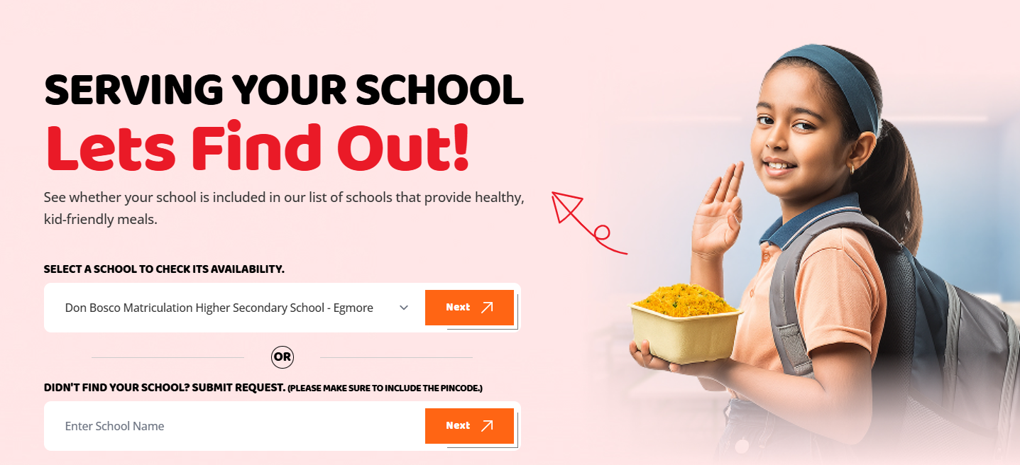
2. Once the user is logged in (registered login), they will be in their account. At this stage, the ‘Next’ button should be hidden
Another one
If the signup is completed but the step-by-step process is skipped, then all pages will still be displayed


Website Content
Home Page:
Banner
Healthy Bites to Fuel Your Child's Mind During School Lunch Time!
Healthy, delectable alternatives that are loaded with vital vitamins and minerals.

About Us Intro
The Mission Behind Lunch Bowl
We strive to simplify mealtime for parents by delivering thoughtfully crafted, nutritionist-approved lunch boxes that are fresh, flavourful and tailored to children’s preferences. Our commitment to high-quality ingredients, eco-friendly packaging and timely delivery ensures that every meal is a blend of convenience, health and happiness.

Food Menu Content
Small Bites, Huge Impact
30+ Healthy Packs
Nutrient-dense, well-portioned meals with a variety of flavors that are intended to entertain and feed kids every day.
6 card listed. you check the content in food menu content.

Serving Your School Let’s Find Out!
See whether your school is included in our list of schools that provide healthy, kid-friendly meals.
- Form field name: Select a school to check its availability.
- Another field content name: Didn’t find your school? Submit Request. (Please make sure to include the Pincode.)
Functionality flow, you check same sheet in functionality page sheet.

How It Works?
See how our site works as soon as you register and create an account with us.
STEP 1: CREATE YOUR ACCOUNT
Begin by easily registering and providing your necessary details. This simple step unlocks a wide selection of nutritious and appealing lunch choices specifically designed for your children.
STEP 2: CHOOSE YOUR MENU
Explore our diverse menu options and select your child's most loved dishes. Feel free to experiment with our range of wholesome meals, catering to various taste and nutritional needs.
STEP 3: PLACE YOUR ORDER
Conveniently plan your preferred delivery schedlue and carefully review all order information system offers a safe and straightfowrd process for finalizing your order.
STEP 4: SIT BACK AND RELAX
Once your order is place, you can rest assured. Our team will prepare a healthy and fresh lunch for your child and ensure it is reliably delivered directly to their school.

Meet the Team Behind the Magic
Experts in creating kid-friendly meals who combined inventiveness and fresh ingredients to create a nourishing and enchanted lunchtime experience.

Explore Nutritious Food First free session awaits you
Subtext:
Sujatha Sasikumar is a Registered Dietitian under the Indian Dietetic Association. She has a Master's in Clinical Nutrition and has her own independent clinical practice in Chennai. She is also certified in Sport Specific Nutrition Management, Nutrigenetics, Critical Care Nutrition and is a Certified Diabetes Educator. She helps people across all age groups modify their eating habits to suit their goals for better health, fitness and performance.

Form Popup Content:
!Talk Nutrition!
Get expert guidance to provide a nutritious future to your little one.

Frequently Asked Questions
Quickly get answers to guarantee a seamless and knowledgeable lunch bowl experience.
FAQ:
1. IN WHAT WAY ARE THE LUNCH DISHES SEALED TO KEEP THEM FRESH AND STOP LEAKS?
Our lunch dishes are tightly sealed with leak-proof, tamper-evident canisters. To assist preserve the freshness of the food and temperature until noon, we use insulated bags for delivery.

2. OVER TIME, WHAT TYPE OF VARIATION CAN I ANTICIPATE IN THE LUNCH BOWL OPTIONS?
We make an effort to provide a varied and ever-changing menu to keep your child engaged. In order to provide a variety of wholesome and enticing options, our culinary team frequently introduces new recipes and seasonal ingredients.

3. WHAT SAFEGUARDS ARE IN PLACE TO GUARANTEE A CLEAN ATMOSPHERE FOR FOOD PREPARATION?
Our cooking facilities are kept to the greatest hygienic standards. All surfaces and equipment are routinely sterilized, our employees wear the proper protective gear, and they adhere to stringent handwashing guidelines. We perform regular inspections and follow food safety laws.

4. HOW CAN I GO ABOUT GIVING COMMENTS OR RESOLVING ANY ISSUE I MIGHT HAVE WITH THE LUNCH BOWLS?
We appreciate your input and invite you to contact our customer service department by phone or email. We are dedicated to immediately resolving any difficulties to ensure your child's satisfaction since we take all complaints seriously.

5. HOW DO YOU ENSURE THE FOOD IS NUTRITIOUS AND SAFE FOR MY CHILD?
Our meals are nutritionist-designed, made with fresh, high-quality ingredients, and prepared under strict hygiene standards. We also customise for dietary needs and take extra care to avoid allergens.

6. HOW DOES THE DELIVERY PROCESS WORK, AND CAN I TRUST IT WILL ARRIVE ON TIME?
We deliver meals directly to schools in temperature-controlled vehicles, timed to arrive just before lunchtime. You’ll receive delivery confirmations, and in the rare case of a delay, we’ll notify you right away.

7. WHAT IF MY CHILD HAS SPECIFIC DIETARY RESTRICTIONS OR ALLERGIES?
We take effort to accommodate allergies and provide menu options that can be customized. Our team follows careful preparation practices to ensure meals are safe and free from cross-contamination.

8. WHAT IF I NEED FOOD ON SUNDAY?
Our regular service is available Monday to Friday. If you require meals on a Sunday, please call us at +91 9176 917602 in advance. Our team will confirm availability and make special arrangements based on your request and delivery location.

9. CAN I GET A FREE TRAIL ON SUNDAY?
We don’t offer free trials on Sundays. Please choose any weekday or Saturday slot for your trial.

10. WHAT IF I DON'T NEED MEAL ON ANY DAY DURING MY SUBSCRIPTION, WILL I GET A REFUND?
The days when you don’t avail meals will get carried forward and gets accumulated in your wallet , which can be redeemed during your next subscription.

11. WHAT IF I WANT TO TERMINATE THE SERVICE?
Termination is possible, and the unconsumed meal days will be calculated and refund will be processed. Request you to contact customer service for termination of services.

CTA
We'd love to hear From You
We are super excited in cooking and providing the best meals to your kids.
Give us a try.
Form Popup Content:
!Reach out We deliver excellence!
We are here to ensure personalized solutions with complete transparency to reach out - contactus@lunchbowl.co.in
Footer:
Fresh, healthy school lunches delivered with care, making mealtime easy for you.
*************************************************************************

ABOUT US:
Banner content:
The Story Behind Every Bite
As food is an emotion, there will be a story
behind every recipe. Let’s explore!

Our Story
Why We Created Lunch Bowl
Let’s be honest—packing lunch every single day is hard work. Between picky eaters, tight mornings, and the never-ending quest for something that’s both healthy and kid-approved, parents (especially moms) are juggling a lot.

That’s where the idea for Lunch Bowl was born.

We asked ourselves:
“What if lunch didn’t have to be another daily stress?”

So, we cooked up a solution: Lunch Bowl is your lunchtime lifesaver. We deliver fresh, delicious, and nutritious meals straight to your child—hot and ready to enjoy. No last-minute chopping, no repeat sandwich cycles, and no lunchbox guilt.

Here’s what we bring to the table:

- Tasty, kid-friendly meals crafted by real nutritionists (and tested by real kids!).
- A fun, easy-to-use meal planning that lets you mix and match based on your child’s tastes.
- Fresh deliveries, right before lunchtime—because soggy sandwiches are so last year.
- Flexible, affordable plans that make sense for busy families.
At Lunch Bowl, we’re here to take one big thing off your plate, while putting something great into your kid’s.

Healthy. Happy. Hassle-free. That’s how we do lunch.

The Mission Behind Lunch Bowl
We strive to simplify mealtime for parents by delivering thoughtfully crafted, nutritionist- approved lunch boxes that are fresh, flavourful and tailored to children’s preferences. Our commitment to high-quality ingredients, eco-friendly packaging and timely delivery ensures that every meal is a blend of convenience, health and happiness.

Meet the team Behind the Magic
Experts in creating kid-friendly meals who combined inventiveness and fresh
ingredients to create a nourishing and enchanted lunchtime experience.

Chef List:
S. Murugan
Executive Chef
He is an award-winning culinary professional with over 25 years of experience, including 13 years in management roles within the hospitality industry. He specializes in innovative cooking, menu development, and streamlining kitchen operations while maintaining high standards of quality and guest satisfaction. With expertise in Continental, Chinese, North Indian, South Indian, Tandoor, Italian, Asian, and European cuisines, he has successfully led culinary teams in various hotels across India and abroad.

Arul Mathan Thangam
Sous Chef
Our Sous Chef, is a skilled culinary professional with expertise in food production, customer service, and maintaining quality standards. With a strong background in preparing diverse cuisines and ensuring proper food handling practices, he excels in creating flavourful dishes while adhering to hygiene and safety protocols. His proficiency in culinary techniques, ingredient preparation, and production processes makes him a reliable and efficient chef dedicated to delivering exceptional dining experiences. Fluent in Tamil, English, and Hindi, he is committed to continuous learning and adapting to new culinary trends.

Vijay Vellanganni
Commis 1
Our Commis 1,a remarkably talented baker and continental cuisine chef. With a flair for baking, Vijay crafts irresistible cookies, brownies, and an array of continental specialties. Beyond sweets, he’s mastered pizzas, puff, pastries, and savory dishes with finesse. Vijay brings professional experience from esteemed hospitality brands such as Pride Hotels, Grand Regent, and Get Sherlock, where his culinary expertise earned respect and praise in high quality hotel kitchens. Whether it's a perfectly chewy chocolate brownie or a crisp, flaky puff, Vijay blends passion and precision in every creation.

Vijay Antony
Commis 3
Our Commis 3, holds a diploma in hotel and catering management from Villupuram. Vijay is a passionate culinary professional with a deep love for cooking. His dedication to the craft, combined with hands-on experience, makes him a promising talent in the world of food and hospitality.

Ravishankar N
Manager Operations
Ravi is an experienced operations specialist and supervisor with a strong background in managing processes across several notable private firms. With a sharp eye for efficiency and a deep understanding of operations, Ravi has consistently driven results through structured execution and team leadership. Now bringing his expertise into the food industry, he is set to apply his operational acumen to streamline workflows, enhance service quality, and contribute to building scalable systems in this dynamic sector.

The vision Behind Lunch Bowl
To make healthy eating effortless for children and stress free for parents, ensuring every child enjoys a nutritious, delicious and exciting lunch everyday.

How it Works?
See how our site works as soon as you register and create an account with us.
STEP 1: CREATE YOUR ACCOUNT
Begin by easily registering and providing your necessary details. This simple step unlocks a wide selection of nutritious and appealing lunch choices specifically designed for your children.
STEP 2: CHOOSE YOUR MENU
Explore our diverse menu options and select your child's most loved dishes. Feel free to experiment with our range of wholesome meals, catering to various taste and nutritional needs.
STEP 3: PLACE YOUR ORDER
Conveniently plan your preferred delivery schedlue and carefully review all order information system offers a safe and straightfowrd process for finalizing your order.
STEP 4: SIT BACK AND RELAX
Once your order is place, you can rest assured. Our team will prepare a healthy and fresh lunch for your child and ensure it is reliably delivered directly to their school.

Our Environment
According to the saying, cleanliness is next to godliness, we make sure our workspace is neat and tidy.

We’d Love to Hear From You
We are super excited in cooking and providing the best meals to your kids. Give us a try.

Footer:
Fresh, healthy school lunches delivered with care, making mealtime easy for you.

*************************************************************************

Contact Us Page :
Banner:
Let’s Cook Up a Conversation
We not only boil, fry and roast the ingredients, but also we love to cook up a conversation with the people we love!

Phone Tab:
Feel free to get in touch
Give us a call today
+91 9176 9176 02

Email Tab:
Write to us
Send us an email
contactus@lunchbowl.co.in

Address Tab:
Where to Find Us
Lunchbowl by Earth Tech Concepts Private Limited
1B, KG Natraj Palace, 53/22,
Saravana Street, T Nagar,
Chennai - 600017

Checkbox Content:
I agree to be contacted by Lunch Bowl via call, SMS, email, or WhatsApp regarding their services.

FAQ:
1. IN WHAT WAY ARE THE LUNC DISHES SEALED TO KEEP THEM FRESH AND STOP LEAKS?
Our lunch dishes are tightly sealed with leak-proof, tamper-evident canisters. To assist preserve the freshness of the food and temperature until noon, we use insulated bags for delivery.

2. OVER TIME, WHAT TYPE OF VARIATION CAN I ANTICIPATE IN THE LUNCH BOWL OPTIONS?
We make an effort to provide a varied and ever-changing menu to keep your child engaged. In order to provide a variety of wholesome and enticing options, our culinary team frequently introduces new recipes and seasonal ingredients.

3. WHAT SAFEGUARDS ARE IN PLACE TO GUARANTEE A CLEAN ATMOSPHERE FOR FOOD PREPARATION?
Our cooking facilities are kept to the greatest hygienic standards. All surfaces and equipment are routinely sterilized, our employees wear the proper protective gear, and they adhere to stringent handwashing guidelines. We perform regular inspections and follow food safety laws.

4. HOW CAN I GO ABOUT GIVING COMMENTS OR RESOLVING ANY ISSUE I MIGHT HAVE WITH THE LUNCH BOWLS?
We appreciate your input and invite you to contact our customer service department by phone or email. We are dedicated to immediately resolving any difficulties to ensure your child's satisfaction since we take all complaints seriously.

5. HOW DO YOU ENSURE THE FOOD IS NUTRITIOUS AND SAFE FOR MY CHILD?
Our meals are nutritionist-designed, made with fresh, high-quality ingredients, and prepared under strict hygiene standards. We also customise for dietary needs and take extra care to avoid allergens.

6. HOW DOES THE DELIVERY PROCESS WORK, AND CAN I TRUST IT WILL ARRIVE ON TIME?
We deliver meals directly to schools in temperature-controlled vehicles, timed to arrive just before lunchtime. You’ll receive delivery confirmations, and in the rare case of a delay, we’ll notify you right away.

7. WHAT IF MY CHILD HAS SPECIFIC DIETARY RESTRICTIONS OR ALLERGIES?
We take effort to accommodate allergies and provide menu options that can be customized. Our team follows careful preparation practices to ensure meals are safe and free from cross-contamination.

8. WHAT IF I NEED FOOD ON SUNDAY?
Our regular service is available Monday to Friday. If you require meals on a Sunday, please call us at +91 9176 917602 in advance. Our team will confirm availability and make special arrangements based on your request and delivery location.

9. CAN I GET A FREE TRAIL ON SUNDAY?
We don’t offer free trials on Sundays. Please choose any weekday or Saturday slot for your trial.

10. WHAT IF I DON'T NEED MEAL ON ANY DAY DURING MY SUBSCRIPTION, WILL I GET A REFUND?
The days when you don’t avail meals will get carried forward and gets accumulated in your wallet , which can be redeemed during your next subscription.

11. WHAT IF I WANT TO TERMINATE THE SERVICE?
Termination is possible, and the unconsumed meal days will be calculated and refund will be processed. Request you to contact customer service for termination of services.

We’d Love to Hear From You
We are super excited in cooking and providing the best meals to your kids. Give us a try.

Footer:
Fresh, healthy school lunches delivered with care, making mealtime easy for you.

*************************************************************************

Terms & Conditions:
Terms & Conditions of Use
Lunch Bowl services are operated by Earth Tech Concepts Private Limited, a company
registered under the Companies Act, 2013, having its registered office at:
1B, KG Natraj Palace, 53/22, Saravana Street, T. Nagar,
Chennai – 600017

By accessing or using our website and services, you agree to the following terms and conditions:

1. Eligibility
Use of the Lunch Bowl service is available only to individuals who can form legally binding contracts under applicable law. By using this website, you represent that you are a parent or legal guardian of the child for whom the service is being ordered.

2. Service Description
Lunch Bowl provides subscription-based nutritious lunch delivery services to school-going children. Services are subject to change, enhancement, or discontinuation at our sole discretion.

3. User Obligations
You agree to:
- Provide accurate and complete registration information.
- Review menu items and communicate any dietary restrictions or allergies.
- Ensure timely payments to maintain uninterrupted service.

4. Ordering and Delivery
Orders must be placed according to our operational calendar. Delivery is restricted to affiliated schools only. While every effort is made to ensure timely delivery, Lunch Bowl is not liable for delays caused by school closures, force majeure events, or third-party disruptions.

5. Modifications and Termination
We reserve the right to amend or terminate services, pricing, or these Terms at any time. Continued use of the website after changes constitutes acceptance.

6. Limitation of Liability
Lunch Bowl shall not be held liable for any direct, indirect, incidental, or consequential damages arising from the use of our services or website.

We’d Love to Hear From You
We are super excited in cooking and providing the best meals to your kids. Give us a try.

Footer:
Fresh, healthy school lunches delivered with care, making mealtime easy for you.

************************************************************************

Privacy Policy
Privacy Policy Statement
Lunch Bowl services are operated by Earth Tech Concepts Private Limited, a company
registered under the Companies Act, 2013, having its registered office at:
1B, KG Natraj Palace, 53/22, Saravana Street, T. Nagar,
Chennai – 600017

This policy outlines how we collect, use, and protect your personal data when you use our website or services.

1. Information Collected
We may collect and store the following types of information:

Parent/guardian name, contact number, and email address
Child’s name, school, class, and dietary preferences
Payment and transaction data (processed via secure third-party gateways)
2. Use of Information
Your information may be used for:

Processing orders and facilitating deliveries
Personalizing menus and accommodating dietary needs
Communicating order updates, service changes, and promotional offers
Internal analytics and service improvement
3. Disclosure of Information
We do not sell or rent your personal data. Your information may be shared with trusted partners (such as delivery or payment providers) strictly for the purpose of fulfilling services.

4. Data Security
We implement reasonable physical, electronic, and managerial safeguards to protect your information. However, no method of transmission over the Internet is 100% secure.

5. User Rights
You may request access, correction, or deletion of your personal data by contacting us at contactus@lunchbowl.co.in

We’d Love to Hear From You
We are super excited in cooking and providing the best meals to your kids. Give us a try.

Footer:
Fresh, healthy school lunches delivered with care, making mealtime easy for you.
*************************************************************************
Refund & Cancellation Policy

Refund & Cancellation Terms
Lunch Bowl services are operated by Earth Tech Concepts Private Limited, a company
registered under the Companies Act, 2013, having its registered office at:
1B, KG Natraj Palace, 53/22, Saravana Street, T. Nagar, Chennai – 600017

This Refund and Cancellation Policy applies to all subscriptions and payments made through our platform.

1. Cancellations
Cancellation requests must be submitted at least forty-eight (48) hours before the scheduled delivery date.
Cancellations requested after the specified period may not be eligible for a refund.
2. Refunds
Refunds are not applicable; however, if an order is cancelled, the amount will be credited to the Lunch Bowl wallet for use in your next meal.

3. Trial Packages
No payment is collected from customers for trial packages.

4. Force Majeure
Refunds do not apply for service disruptions caused by events beyond our control, including but not limited to natural disasters, strikes, school holidays, or transport failures.

We’d Love to Hear From You
We are super excited in cooking and providing the best meals to your kids. Give us a try.

Footer:
Fresh, healthy school lunches delivered with care, making mealtime easy for you.

****************************************************************

FOOD MENU: CONTENT
1. BANNER -
Heading:
TINY TASTY BOWL HEALTHY WHOLE
Subtext:
Fuel your little one’s day with our specially themed KID’S LUNCH BOWL; wrapped with fresh veggies, delicious flavors and wholesome grains they will love — NUTRITIOUS for them and WORRY-FREE for you.
2nd Section Content:
Heading:
The Mission Behind 30+ Nutritious Picks
Subtext:
Select your child’s go-to cuisine and check out what’s on the menu.
3rd Section Content:
Items are:
1. Arabbiata Pasta and Garlic Bread

Pasta tossed in a fiery arrabiata sauce made with tomatoes, garlic, and chili. Served with garlic bread for a fiery, filling combo.

Ingredients
Penne pasta – 100g
Garlic bread – 30g
Tomatoes – 30g
Garlic – 10g
Red chili paste – 5g
Green bell pepper – 10g
Olive oil – 10ml
Butter – 15g
Cheese – 10g
Dry herbs – 2g
Nutrition Value
Calories: 486
Carbohydrates: 51
Proteins: 12
Fats: 25
Fibre: 3.7
2. Pav Bhaji
A buttery mash of mixed vegetables cooked in special spices, served with toasted pav. A Mumbai favorite that hits all the right notes spicy, tangy, and comforting.
Ingredients
Pav bun (outsource) – 100g, Capsicum – 10g, Green peas – 20g, Potatoes – 30g, Spices – 10g, Butter – 20g, Onions – 10g, Tomatoes – 10g, Ginger garlic paste – 10g, Salt – to taste
Nutrition Value
Calories: 455
Carbohydrates: 51g
Proteins: 10g
Fats: 26g
Fiber: 6.5g
3. Steamed Momos and Hot Garlic Sauce
Steamed vegetable momos paired with a bold, spicy garlic sauce. Light, flavorful, and satisfyingly spicy.
Ingredients
- Refined flour – 150g
- Paneer – 35g
- Onion – 3g
- Jeera – 1 tsp
- Chilli powder – a pinch
- Green chilli – 1 no
- Salt – to taste
- Refined oil – 20ml (for greasing, steam only)
- Butter – 15g
- Garlic – 10g
- Chilli sauce with tomato sauce – 10g
Nutrition Value
- Calories: 755
- Carbohydrates: 111g
- Proteins: 21g
- Fats: 23g
- Fiber: 15g

4. Phulka – Aloo Mutter
Soft phulkas served with a comforting aloo mutter curry—potatoes and peas simmered in a mildly spiced tomato gravy. Simple, wholesome, and timeless.
Ingredients
- Phulka: Atta – 140g, Salt – a pinch
- Aloo Mutter: Potatoes – 70g, Green peas – 30g, Onion – 30g, Tomatoes – 20g, Cashewnut – 20g
Nutrition Value
- Calories: 781
- Carbohydrates: 126g
- Proteins: 29g
- Fats: 17g
- Fiber: 24g

5. Ragi Arrabbiata Pasta – Garlic Bread
A unique fusion—fiber-rich ragi pasta tossed in a spicy arrabiata sauce, paired with garlic bread. Bold flavors, guilt-free pleasure.
Ingredients
- Pasta (Ragi) – 150g
- Tomato – 50g
- Green pepper – 15g
- Red pepper – 15g
- Butter – 30g
- Cheese – 20g
- Carrot – 10g
- Chilli flakes – 5g
- Tomato sauce – 15g
Nutrition Value
- Calories: 570
- Carbohydrates: 62g
- Proteins: 16g
- Fats: 31g
- Fiber: 5g

6. Sambar Rice – Coined Baby Potato Fry
Comforting sambar rice made with toor dal and vegetables, served with golden-fried baby potatoes. Traditional yet indulgent.
Ingredients
- Rice – 110g
- Toor dal – 50g
- Mixed vegetables (country veg) – 25g
- Sambar powder – 15g
- Ghee – 15g
- Oil – 10g
- Jeera – 3g
- Asafoetida – 1 pinch
Nutrition Value
- Calories: 406
- Carbohydrates: 34g
- Proteins: 5g
- Fats: 27g
- Fiber: 2.5g

7. Thai Green Curry – with Butter Rice
Aromatic Thai green curry made with coconut milk, herbs, and vegetables, served with fragrant steamed rice. Creamy, zesty, and refreshing.
Ingredients
- Basmati rice – 100g
- Onion – 10g
- Tomatoes – 15g
- Green chilli – 2 nos
- Ghee/olive oil – 40ml
- Lemongrass – 2 nos
- Coriander leaves – 2g
- Garlic – 3 nos
- Lime leaves – 2 nos
- Jeera – 3 nos
- Cauliflower – 10g
- Broccoli – 10g
- Beans – 10g
- Coconut milk – 15ml
- Potatoes – 15g
- Turkey berry – 10g
- Mushroom – 10g
- Chopped bell pepper – 10g
Nutrition Value
- Calories: 307
- Carbohydrates: 39g
- Proteins: 5g
- Fats: 14g
- Fiber: 5g

8. Coconut Pulav – Crispy Bhindi & Peanut Fry
Fragrant coconut-flavored pulav cooked with mild spices, paired with crispy fried bhindi and roasted peanuts. A delightful South Indian meal that’s both light and flavorful with the perfect mix of softness and crunch.
Ingredients
- Raw rice – 150g
- Grated coconut – 30g
- Coconut oil – 30ml
- Green chilli – 1 no
- Cashew – 5g
- Peanut – 5g
- Ghee – 1 tsp
- Mustard seeds, Urad dal, Red chilli, Curry leaves – 5g
- Brown channa – 100g
- Grated coconut – 5g
Nutrition Value
- Calories: 712
- Carbohydrates: 57g
- Proteins: 12g
- Fats: 50g
- Fiber: 7g

9. Steamy Rice and Dal Makhani
Soft steamed rice paired with creamy, slow-cooked dal makhani—rich in flavor, hearty in feel. A timeless pairing with depth in every bite.

Ingredients
Rajma dal – 30g, Steam rice – 100g, Black gram dal – 30g, Fresh cream – 10ml, Garam masala – 2g, Ginger garlic paste – 10g, Jeera powder – 3g, Kashmiri chilli powder – 5g, Butter – 10g, Ghee – 10g, Onion – 10g, Tomatoes – 10g

Nutrition Value
Calories: 380
Carbohydrates: 39
Proteins: 7.5
Fats: 21
Fiber: 4
10. VEG BIRYANI – RAITA
This vibrant vegetable biryani is infused with aromatic spices and layered flavors. Paired with soothing raita, every bite brings a perfect balance.

Ingredients
Basmati rice – 100g, Mixed vegetables – 30g, Onions – 10g, Tomatoes – 10g, Ginger garlic paste – 10g, Whole garam masala – 5g, Chili powder – 2g, Green chilly – 3g, Ghee – 20ml, Cashew nuts – 5g, Mint & coriander leaves – 5g, Salt – to taste

Nutrition Value
Calories: 372
Carbohydrates: 35
Proteins: 5
Fats: 23
Fiber: 2.5
11. MINT PARATHA – KASHMIRI KOFTA
Fresh mint parathas bring a herby twist to your plate, perfectly complementing the rich, creamy Kashmiri kofta. A regal dish with bold flavors.

Ingredients
Whole wheat flour – 50 gm, Butter – 20 ml, Mint – 10 gm, Potatoes – 30 gm, Green chilly – 2 gm, Jeera powder – 2 gm, Cashewnut – 40 gm, Methi leaves – 2 gm, Dry fruits – 5 gm, Milk – 30 ml, Ghee – 20 gm, Oil – 20 gm

Nutrition Value
Calories: 775
Carbohydrates: 49
Proteins: 15
Fats: 57
Fiber: 7
12. DAL KHICHDI – BABY POTATO FRY
Warm, spiced dal khichdi offers hearty comfort, while golden-fried baby potatoes add a satisfying crunch. A cozy, yet exciting meal.
Ingredients
Moong dal – 100 gm, Raw rice – 100 gm, Ghee – 30 gm, Jeera powder – 5 gm, Turmeric powder – a pinch, Mixed vegetables (optional) – 500 gm, Asafoetida – a pinch, Salt to taste, Sambar powder – 2 pinches, Potatoes – 30g, Masala – 10g, Curry leaves and coriander – 3g.
Nutrition Value
Calories: 145
Carbohydrates: 37
Proteins: 18
Fats: 33
Fiber: 2
13. CREAMY SPINACH AND CORN AUGRATIN
A decadent blend of spinach and sweet corn in a creamy béchamel sauce, topped with golden cheese. A cozy bake that’s pure comfort.
Ingredients
Butter – 50 gm, Refined flour – 25 gm, Milk – 125 ml, Spinach – 30 gm, Corn – 15 gm, Dry herbs – a pinch, Cheese – 20 gm
Nutrition Value
Calories: 751
Carbohydrates: 41
Proteins: 15
Fats: 59
Fiber: 4

14. VEG NOODLES WITH VEG MANCHURIAN
Street-style stir-fried noodles with crunchy veggies, served with juicy Manchurian balls in a spicy sauce. A favorite Indo-Chinese combo.
Ingredients
Hakka noodles – 100g, Cabbage – 30g, Carrot – 30g, Beans – 30g, Capsicum – 30g, Onions – 30g, Spring onions – 10g, Ginger garlic paste – 20g, Corn flour – 10g + 15g, Oil – 40g, Chilli pastes – 5g, Soya sauce – 5ml, Tomato sauce – 5ml, Butter – 15g
Nutrition Value
Calories: 1041
Carbohydrates: 68
Proteins: 10
Fats: 79
Fiber: 11
15. SAFFRON AND NUTS RICE – KADAI VEG
Long-grain basmati rice infused with saffron and garnished with crunchy nuts, paired with spicy and colorful Kadai vegetables sautéed in a tangy tomato-based masala. A luxurious and balanced North Indian experience.
Ingredients
Basmati rice – 100 gm, Ghee – 30 gm, Almond – 10 gm, Pista – 10 gm, Cashew – 30 gm, Whole garam masala – 2 gm, Onion – 15 gm, Tomatoes – 10 gm, Capsicum – 10 gm, Kashmiri chilli powder – 4 gm, Ginger-garlic paste – 10 gm, Butter – 20 gm, Jeera powder – 3 gm, Mixed vegetables – 50 gm
Nutrition Value
Calories: 715
Carbohydrates: 43
Proteins: 15
Fats: 54
Fiber: 6
16. Phulka – Paneer Butter Masala
Soft phulkas served with a creamy and mildly spiced paneer butter masala. A classic North Indian combo that delivers homely comfort with a restaurant-style indulgence.
Ingredients
Paneer – 100g, Cashew nuts – 15g, Tomatoes – 15g, Onions – 15g, Garam masala – 5g, Ginger garlic paste – 15g, K. chilli powder – 5g, Wheat flour – 40g, Jeera powder – 2g, Dry Methi leaves – 2g, Butter – 20ml
Nutrition Value
Calories: 671
Carbohydrates: 50
Proteins: 28
Fats: 39
Fiber: 5.7

17. Phulka – Paneer Butter Masala
Soft phulkas served with a creamy and mildly spiced paneer butter masala. A classic North Indian combo that delivers homely comfort with a restaurant-style indulgence.
Ingredients
Paneer – 100g, Cashew nuts – 15g, Tomatoes – 15g, Onions – 15g, Garam masala – 5g, Ginger garlic paste – 15g, K. chilli powder – 5g, Wheat flour – 40g, Jeera powder – 2g, Dry Methi leaves – 2g, Butter – 20ml
Nutrition Value
Calories: 671
Carbohydrates: 50
Proteins: 28
Fats: 39
Fiber: 5.7

18. Veg Kati Roll – Katta Meeta Sauce
Stuffed with a mix of sautéed vegetables and spices, this soft roll is paired with a tangy-sweet khatta meeta sauce. Convenient, flavorful, and fun.
Ingredients
Wheat flour – 50g, Mixed vegetables – 50g, Onion – 10g, Tomatoes – 10g, Butter – 20g, Dates – 3 nos, Ajwain – 2g, Tamarind – 20ml, Jaggery – 20g, Jeera powder – 2g, Chaat masala – 2g
Nutrition Value
Calories: 562.6
Carbohydrates: 87
Proteins: 8
Fats: 21
Fiber: 10
19. METHI ALOO PARATHA - RAITA
Flaky flatbreads stuffed with seasoned potatoes and fenugreek, served with cool raita. Packed with flavor, this meal is as wholesome as it is delicious.
Ingredients
Wheat flour – 50g, Methi – 2g, Potato – 40g, Green chilli – 2g, Mint & coriander leaves – 4g, Jeera powder – 3g, Curd – 50ml, Veg pickle – 10g
Nutrition Value
Calories: 229
Carbohydrates: 40
Proteins: 8
Fats: 4
Fiber: 7
20. AGLIO E OLIO PASTA – GARLIC BREAD
Olive oil, garlic, and chili flakes coat perfectly cooked pasta in this minimalist Italian classic. Served with cheesy garlic bread.
Ingredients
Garlic – 20 nos, Red pepper – 1 no (3g), Spaghetti – 100g, Olive oil – 25ml, Pepper – 2g, Parsley – 10g, Garlic bread – 40g, Cheese – 30g
Nutrition Value
Calories: 675
Carbohydrates: 76
Proteins: 18
Fats: 34
Fiber: 8
21. VEG FRIED RICE – VEG IN BLACK BEAN SAUCE
Fluffy fried rice with veggies, paired with a bold black bean sauce stir-fry. A Chinese-style duo that brings deep savory notes.
Ingredients
Fried Rice: Basmati rice – 125 gm, Carrot – 15 gm, Beans – 15 gm, Cabbage – 15 gm, Corn – 100 gm, Capsicum – 150 gm, Onion – 100 gm, Spring onion – 50 gm, Salt, pepper, cornflour – as required, Butter (or Refined oil) – 20 ml Manchurian: Mixed vegetables – 150 gm, Onion – 50 gm, Garlic – 10 gm, Capsicum – 150 gm, Ginger – 5 gm, Sauces – 10 ml, Oil – 50 ml
Nutrition Value
Calories: 527
Carbohydrates: 57
Proteins: 10
Fats: 29
Fiber: 6

22. LEMON RICE – SLICED POTATO FRY
Tangy lemon rice seasoned with mustard seeds and curry leaves, paired with crisp fried potato slices. Refreshing and filling.
Ingredients
Raw rice – 150 gm, Lemon juice – 1 no, Green chilli – 1 no, Gingelly oil – 25 ml, Ghee – 1 tsp, Turmeric powder – a pinch, Cashew – 5 gm, Peanut – 5 gm, Salt – to taste, Mustard seeds – 1 tsp, Urad dal – 1 tsp, Curry leaves – few, Coriander leaves – chopped (for garnish), Potatoes – 60 gm, Ghee or refined oil – 25 ml, Sambar powder – 1 tsp, Salt – a pinch.
Nutrition Value
Calories: 406
Carbohydrates: 34
Proteins: 5
Fats: 27
Fiber: 2.5

23. Spaghetti with Pink Sauce and Garlic Bread
Spaghetti in a blush pink sauce that balances tomato tang and creaminess, served with garlic bread. Every twirl is rich and smooth.
Ingredients
Spaghetti – 125 gm, Tomatoes – 50 gm, Garlic – 10 gm, Red pepper – 15 gm, Green pepper – 100 gm, Onion – 15 gm, Chilly flakes – a pinch, Olive oil – 20 ml, Butter – 25 gm, Milk – 50 ml, Flour – 20 gm, Dry herbs – as taste, Tomato sauce – 15 gm
Nutrition Value
Calories: 735
Carbohydrates: 75
Proteins: 14
Fats: 44
Fiber: 6.9
24. Paneer Bao - with Butter garlic Saute Vegetables
Soft steamed bao buns filled with spiced paneer, served alongside sautéed vegetables in butter and garlic. Global street food meets Indian flavor.
Ingredients
Mixed vegetables (corn, carrot, cauliflower, beans, cabbage) – 150 gm, Pick of dry herbs – as required, Butter – 15 gm, Garlic – 15 gm, Paneer (cottage cheese) – 60 gm, Refined flour – 70 gm
Nutrition Value
Calories: 532
Carbohydrates: 34
Proteins: 17
Fats: 36
Fiber: 2
25. PHULKA AND CHANNA MASALA
Soft phulkas served with robust chana masala—chickpeas simmered in a spicy tomato base. A staple that’s full of punch and personality.
Ingredients
Wheat flour – 40g, Chick peas – 30g, Onions – 15g, Tomato – 15g, Butter/oil – 20ml, Channa masala – 10g, Ginger garlic paste – 15g, Garam masala – 5g, Salt – to taste
Nutrition Value
Calories: 431
Carbohydrates: 48
Proteins: 12
Fats: 20
Fiber: 7.5
26. Paneer Pulav - Chatpata Raita
Fragrant paneer pulao tossed with aromatic spices and soft cottage cheese cubes, paired with tangy chatpata raita. A balanced blend of warmth and zing.
Ingredients
Basmati rice – 125 gm, Cottage cheese – 75 gm, Onion – 15 gm, Cardamom – 1 no, Mint – 5 gm, Coriander – 5 gm, Curry masala – 30 gm, Ghee – 20 ml, Clove – 1 no, Cinnamon – 1 no, Bayleaf – 1 no
Nutrition Value
Calories: 532
Carbohydrates: 34
Proteins: 17
Fats: 36
Fiber: 2
27. Jeera Rice - Aloo Mutter
Fluffy jeera rice paired with aloo mutter in a lightly spiced gravy. A gentle, comforting dish that brings warmth to every meal.
Ingredients
Basmati rice – 125 gm, Ghee – 20 ml, Cumin seed – 5 gm, Bay leaf – 1 no, Green chilly – 1 no, Fried onion – 10 gm, Garam masala – a pinch
Nutrition Value
Calories: 663
Carbohydrates: 69
Proteins: 173
Fats: 35
Fiber: 10
28. VEG PULAV AND RAITA
Light and fragrant vegetable pulao served with creamy raita. A wholesome and colorful plate that brings joy in every spoonful.
Ingredients
Basmati rice - 100gm, Cashewnut - 20gm, Mint - 20gm, G.G paste - 10gm, Ghee - 25ml, Onion - 10gm, Maise - 2gm, Cardamom - 2gm, Green chilly - 2gm, Yogurt - 30gm, Cucumber - 15gm, Carrot - 10gm.
Nutrition Value
Calories: 712
Carbohydrates: 57
Proteins: 12
Fats: 50
Fiber: 7

29. VEG ALFREDO PASTA - GARLIC BREAD
Silky Alfredo pasta made with vegetables and rich cream sauce, served with crisp garlic bread. A continental classic done right.
Ingredients
Alfredo pasta – 100g, American corn – 10g, Broccoli – 15g, Mushroom – 10g, Olive oil – 20ml, Garlic bread – 30g, Butter – 20g, Cheese – 10g, Seasoning – 5g
Nutrition Value
Calories: 605
Carbohydrates: 50
Proteins: 12
Fat: 40
Fiber: 3.7
30. CREAMY CURD RICE – POTATO ROAST
Chilled, creamy curd rice tempered with mustard and curry leaves, served with golden roasted potatoes. A soothing, nostalgic meal.
Ingredients
Raw rice – 100g, Curd – 50g, Milk – 50g, Potatoes – 30g, Masala – 10g, Curry leaves and coriander – 3g, Oil – 20ml
Nutrition Value
Calories: 423
Carbohydrates: 40
Proteins: 7
Fats: 25
Fiber: 1.4
31. COCONUT RICE – BROWN CHANA PORIYAL
Aromatic coconut rice with tempered spices, paired with seasoned brown chana poriyal. A tropical, protein-packed meal.
Ingredients
Raw rice – 150 gm, Grated coconut – 30 gm, Coconut oil – 30 ml, Green chilli – 1 no, Cashew – 5 gm, Peanut – 5 gm, Ghee – 1 tsp, Mustard seeds, Urad dal, Red chilli, Curry leaves – 5 gm, Brown channa – 100 gm, Grated coconut – 5 gm.
Nutrition Value
Calories: 406
Carbohydrates: 34
Proteins: 20
Fats: 27
Fiber: 2.5
32. PANEER KATI ROLL – WITH KHATTA MEETHA SAUCE
Spiced paneer rolled in a soft wrap, paired with katta meetha sauce. A tasty, on-the-go North Indian snack.
Ingredients
Paneer – 75g, Wheat flour – 50g, Capsicum, Onion, Tomatoes – 35g (combined), Butter – 10g, Dates – 3 nos, Ajwain – 2g, Tamarind – 20ml, Jaggery – 20g, Jeera powder – 2g, Chaat masala – 2g
Nutrition Value
Calories: 656
Carbohydrates: 93
Proteins: 21
Fats: 22
Fiber: 10
33. Veg Pizza
A delicious hand-tossed base topped with fresh vegetables, tangy tomato sauce, and a generous layer of melting cheese. Every bite brings you the perfect balance of crispiness, freshness, and cheesy indulgence.
Ingredients
All-purpose flour – 100 g, sugar – 5 g, salt – 5 g, yeast – 5 g, sooji – 7 g, oil – 5 ml, mozzarella cheese – 120 g, three-colour
Nutrition Value
Calories - 748
Carbohydrates - 83
Proteins - 36
Fats - 28
Fiber - 17
34. Poha
Light and fluffy poha cooked with onions, mustard seeds, and curry leaves, served with a flavourful chutney. A nourishing breakfast favourite that’s gentle on the stomach and packed with comforting flavours.
Ingredients
White poha – 50 g, oil – 10 ml, salt to taste, jeera – 10 g, peanuts – 20 g, onion – 30 g, tomato – 20 g, curry leaves – 5 g, turmeric powder – 5 g, jeera powder – 10 g, ghee – 20 ml, lemon – ¼ no, coriander leaves – 10 g, mustard seeds – 10 g, and urid dal (white) – 5 g.
Nutrition Value
Calories - 572
Carbohydrates - 45
Proteins - 9
Fats - 40
Fiber - 3
School details - Client provided
- DAV Girls Senior Secondary School - GOPALAPURAM
- Don Bosco School of Excellence - EGMORE
- Don Bosco Matriculation Higher Secondary School - EGMORE
- Bhavans Rajaji Vidyashram - KILPAUK
- Chennai Public School - ANNA NAGAR
- Alphabet - PALAVAKKAM
- ST Francis Xavier English Medium Matriculation School - ALWARPET
- Maharishi Vidyamandir Senior Secondary School - CHETPET
- SBOA Matriculation and Higher Secondary School - ANNA NAGAR
- Velammal Vidyalaya - 1. Maduravoyal, 2. Porur, 3. Mogappair
- Sishya School - ADYAR
- St Francis Xavier - ALWARPET
- Chinmaya Vidyalaya - KILPAUK
- DAV Boys Senior Secondary School - GOPALAPURAM
- Holy Angels Anglo Indian Higher Secondary School - T. NAGAR
- Bala Vidya Mandir - ADYAR
- Sprouts Montessori - ALWARPET
- Chinmaya Vidyalaya Senior Secondary School - ANNA NAGAR
- MCTM International School - ALWARPET
- Padma Seshadri Bala Bhavan Senior Secondary School - KK NAGAR
- Narayana Olympiad School - GOPALAPURAM
SCHOOL TIMING: LUNCH
11 am to 12 pm
12 pm to 1 pm
**********************************************************************
STEPS Content:
Offers available in subscription:
- Save 5% on the 66 Working Days Plan.
- Save 10% on the 132 Working Days Plan.
- Discounts do not apply to custom date selections.
Note: Per Day Meal = Rs. 200 (No. of Days × Rs. 200 × 1 child = Subscription Amount)
Payment:

Complete Payment

Secure payment via CCAvenue
We have curated our payment system with the finest level of security ensuring a smooth and dependable experience.
**********************************************************************
Example Menu list for 22 working days
Meal Plan
DAY MEAL
Day 01- Pav Bhaji
Day 02- Creamy Spinach & Corn Augratin
Day 03- Paneer Bao -Butter and Garlic Saute Vegetables
Day 04- Coconut Rice & Brown Chana Poriyal
Day 05- Veg Pulav & Raita
Day 06- Veg Noodle - Veg Manchurian
Day 07 - Veg Biriyani - Raita
Day 08 - Veg Alfredo Pasta - Garlic Bread
Day 09 - Veg Fried Rice - Veg in Black Bean Sauce
Day 10 - Lemon Rice & Sliced Potato Fry
Day 11 - Jeera Rice - Aloo Mutter
Day 12 - Paneer Katti Roll - Katta Meeta Sauce
Day 13 - Multi Millet Chapati - Paneer Lababdar
Day 14 - Ragi Arabiata pasta and garlic bread
Day 15 - Phulka - Paneer Butter Masala
Day 16 - Steamed Momos and Hot Garlic sauce
Day 17 - Multi Millet Chapati - Paneer Lababdar
Day 18 - Thai Green Curry - Butter Rice
Day 19 - Aglio E Olio Pasta - Cheesy Garlic Bread
Day 20 - Coconut Pulav with Crispy Bhindi and Peanut Fry
Day 21 - Phulka - Channa Masala
Day 22 - Creamy Curd Rice with Potato Roast
Day 23 - Pav Bhaji
Day 24 - Creamy Spinach & Corn Augratin
Day 25 - Paneer Bao - Butter and Garlic Saute Vegetables
Day 26 - Coconut Rice & Brown Chana Poriyal
Day 27 - Veg Pulav & Raita
Day 28 - Veg Noodle - Veg Manchurian
Day 29 - Veg Biriyani - Raita
Day 30 - Veg Alfredo Pasta - Garlic Bread
Day 31 - Veg Fried Rice - Veg in Black Bean Sauce
********************************************************************
My Account
Dashboard -
Banner Content:

HEALTHY BITES JOYFULL SMILES

!HEY! CONFUSED ALREADY? — We are here with full pack of protein fiber
and also an appetizing meal bowl for your little one; so no more worries
of lunch bowl for our little smiles.

Websites Links

Lunch Bowl Site Links

- Home Page: https://lunchbowl.co.in/
- About Us page: https://lunchbowl.co.in/about-us
- Food Menu Page: https://lunchbowl.co.in/Menulist
- Contact Us Page: https://lunchbowl.co.in/contact-us
- Terms and Conditions: https://lunchbowl.co.in/terms-and-conditions
- Privacy Policy: https://lunchbowl.co.in/privacy-policy
- Refund Policy: https://lunchbowl.co.in/refund-cancellation-policy
- Register Form Page : https://lunchbowl.co.in/user/profile-Step-Form
- Payment Page : https://secure.ccavenue.com/transaction/transaction.do?command=initiateTransaction
- Menu Calendar Page: https://lunchbowl.co.in/user/menuCalendarPage
- Dashboard Page: https://lunchbowl.co.in/user/userDashBoard
- My account Page: https://lunchbowl.co.in/user/my-account
- Free Trial Page: https://lunchbowl.co.in/free-trial
- Facebook: https://www.facebook.com/people/Lunch-Bowl/61576363797904/?rdid=DhGcYqyqO8GZkobq&share_url=https%3A%2F%2Fwww.facebook.com%2Fshare%2F1CChGD5qf6%2F
- Instagram: https://www.instagram.com/lunch_bowl_/?igsh=d3kxM3k3cHJwc2F0#

Functionality All Page
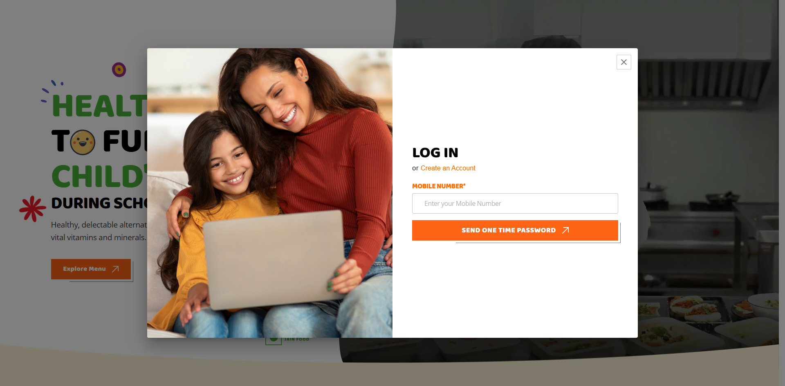

Page Name: Home page / About Us page / Food menu page / Contact us page
Section: Log-in (Button)
Description: The login functionality of Lunch Bowl allows registered users to access their personalized account and menu calendar using their mobile number and OTP (One-Time Password). This ensures security without requiring a traditional password. The system validates the mobile number format, checks registration status, and uses an OTP mechanism for authentication.

Functionality Documentation – Lunch Bowl Site (Login & Signup Flow)

1. Overview
The Lunch Bowl site provides a login mechanism that works through mobile number and OTP verification. Users can either log in if they are already registered or create a new account through the signup flow. OTP-based authentication ensures secure access.

2. Components
- Login Button (on all pages, top-right corner)
  - Opens the login popup.
- Login Popup
  - Contains the Mobile Number Field.
  - Send OTP button.
  - Create an Account link (opens Signup popup).
- Signup Popup
  - Collects details for new users such as name, mobile number, etc.
  - After successful signup, the user can log in with OTP.
- OTP Popup
  - Field to enter OTP.
  - 2-minutes timer.
  - Option to resend OTP if expired.

3. Functional Flow

A. Login Popup
- Mobile Number Field Validation
  - Input must be 10 digits.
  - Must start with 6, 7, 8, or 9.
  - If validation fails → show error message: “Please enter a valid mobile number.”
- Send OTP button
  - If the number is not registered → Show message: “Your mobile number is not registered.”
  - If the number is registered → Open OTP popup and send the OTP to the entered mobile.

B. OTP Verification
- OTP Popup Contents
  - Field to enter OTP.
  - "Verify" button.
  - Timer: 2 mins countdown.
  - Before the timer expires → only "Verify" option available.
  - After timer expires → "Send One Time OTP" button changes to "Resend OTP."
- Scenarios
  - If OTP is incorrect → Show message: “Invalid OTP”.
  - If OTP is correct → Show success message: “Successfully logged in” and navigate:
    - If profile is complete (already registered): → Menu Calendar Page.
    - If only signed up but not completed registration → Registration Page to complete details.

C. Signup Flow
- From the login popup, clicking “Create an Account” → opens the signup popup.
- The user provides details and registers.
- After signup:
  - If mobile number is unique → Registration successful → User redirected to registration page.
  - If mobile number already exists → Show error “Mobile number already registered; please log in instead.”

4. Error & Success Messages
- “Please enter a valid mobile number.” – if the number fails validation.
- “Your mobile number is not registered.” – if number not found.
- “Invalid OTP” – if entered OTP is incorrect.
- “Successfully logged in” – after correct OTP verification.
- “Mobile number already registered, please login instead.” – during signup if number exists.

5. Navigation Summary
- Login Success (Registered User) → Menu Calendar Page.
- Signup Success → Registration Page.
- Not registered mobile in login → Error message.
- Wrong OTP → Error message (remain on OTP popup).
- OTP Expired → Show "Resend OTP."

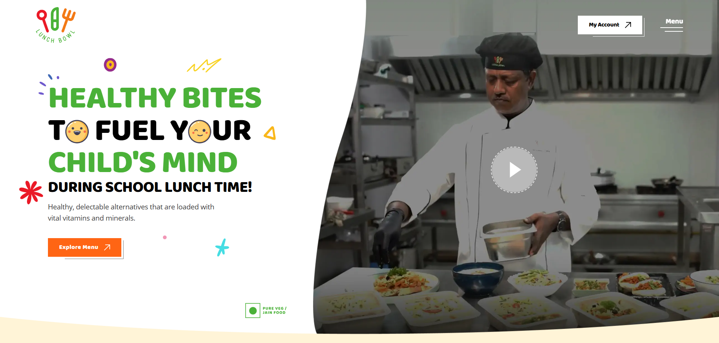
Page Name: Home
Section: Banner
Section Number: 01

1. Overview
The top section of the Home page is visually split into two parts:
- Right side: Displays a video showcasing the cooking process of Lunch Bowl meals.
- Left side: Contains a brief 4-line content describing Lunch Bowl, along with an “Explore Menu” button for user navigation.

2. Button Behavior: Explore Menu
- On clicking “Explore Menu”, the user is navigated to the Food Menu page.
- The Food Menu page presents the complete list of Lunch Bowl meals and options available for order.
- Navigation should be smooth and maintain the user’s browsing context.

3. Right Side Video
- The cooking video plays or is available for play, showcasing Lunch Bowl meal preparation.
- The video is visible on all device sizes as per responsive design.

4. Expected User Flow
- User lands on Home page.
- User reads the Lunch Bowl summary on the left.
- If interested, clicks “Explore Menu” button.
- User is redirected to Food Menu page with full menu listing.

5. Error Handling
- If navigation fails for any reason (e.g., network issue), show a user-friendly message or retry option.
- Video loading or playback errors should not break page layout.

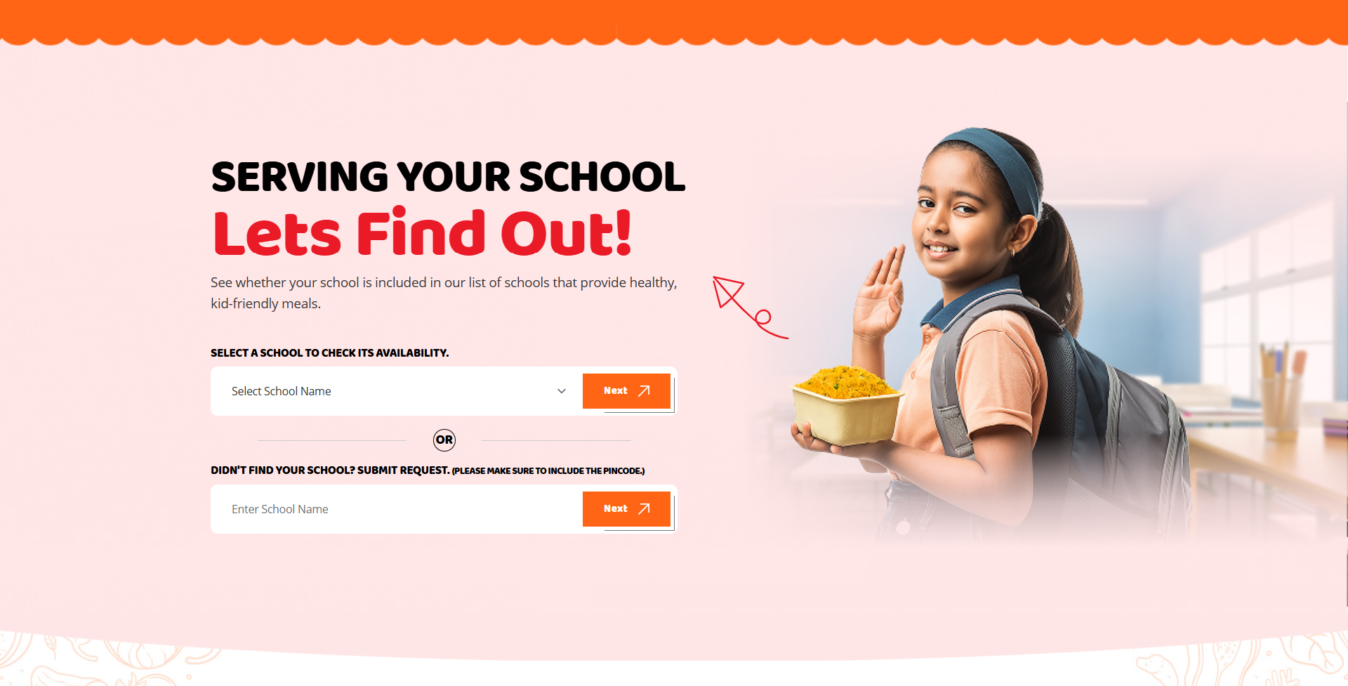

Page Name: Home
Section: Serving your school Lets Find Out!
Section Number: 04
Description: The “Serving Your School—Let’s Find Out!” section helps parents quickly find out whether their child’s school is already being served by the client and also provides an option to request service if the school is not yet included.

Overview:
This section allows parents/guardians to check whether their child’s school is currently being served by the client.
It provides two main flows:
- Check School Availability & Sign Up
- Submit Request if School Not Found

User Flows

Flow 1 – Select Existing School
- Field 1: “Select a school to check its availability.”
  - A dropdown/list will display schools that the client is already serving.
  - The user selects the school where their child is studying.
- Next Button Action
  - On clicking Next, the system checks that a school has been selected.
  - The user is navigated to the Sign-Up Popup Form.
- Sign-Up Popup Form
  - Fields Required:
    - Name (Mandatory)
    - Mobile Number (Mandatory)
    - Email ID (Mandatory)
  - Action:
    - On clicking “Sign Up,” details are submitted, and the user can explore available plans for their school.

Flow 2 – Submit Request for a New School
- Field 2: “Didn’t find your school? Submit Request.”
  - The user enters the school name (free text entry).
- Next Button Action
  - On clicking Next, the system navigates to the Request Submission Popup.
- Request Submission Popup
  - Fields available:
    - School Name (Pre-filled with previous input, but editable if needed)
    - Name (Mandatory)
    - Mobile Number (Mandatory)
    - Message (Optional)
  - Action:
    - On clicking “Submit Request,” the request is sent to the client.
    - The client receives the details and can contact the parent/guardian for further updates.

Validation Rules
- Mandatory Fields:
  - Sign-Up Popup → Name, Mobile, Email.
  - Request Popup → School Name, Name, Mobile.
- Optional Field: Message in Request Popup.
- Mobile numbers should be validated for correct format.
- Email ID should be validated for standard email format.

Output / Expected Results
- Existing School Selection → The user completes signup and gets access to available plans.
- New School Request → The user request is logged with the client for future contact.

Overview
This section allows parents/guardians to check whether their child’s school is currently being served by the client.
It provides two main flows:
- Check School Availability & Sign Up
- Submit Request if School Not Found

User Flows

Flow 1 – Select Existing School
- Field 1: “Select a school to check its availability.”
  - A dropdown/list will display schools that the client is already serving.
  - The user selects the school where their child is studying.
- Next Button Action
  - On clicking Next, the system checks that a school has been selected.
  - The user is navigated to the Sign-Up Popup Form.
- Sign-Up Popup Form
  - Fields Required:
    - Name (Mandatory)
    - Mobile Number (Mandatory)
    - Email ID (Mandatory)
  - Action:
    - On clicking “Sign Up”, details are submitted, and the user can explore available plans for their school.

Flow 2 – Submit Request for a New School
- Field 2: “Didn’t find your school? Submit Request.”
  - The user enters the school name (free text entry).
- Next Button Action
  - On clicking Next, the system navigates to the Request Submission Popup.
- Request Submission Popup
  - Fields available:
    - School Name (Pre-filled with previous input, but editable if needed)
    - Name (Mandatory)
    - Mobile Number (Mandatory)
    - Message (Optional)
  - Action:
    - On clicking “Submit Request,” the request is sent to the client.
    - The client receives the details and can contact the parent/guardian for further updates.

Validation Rules
- Mandatory Fields:
  - Sign-Up Popup → Name, Mobile, Email.
  - Request Popup → School Name, Name, Mobile.
- Optional Field: Message in Request Popup.
- Mobile numbers should be validated for correct format.
- Email ID should be validated for standard email format.

Output / Expected Results
- Existing School Selection → The user completes signup and gets access to available plans.
- New School Request → The user request is logged with the client for future contact.

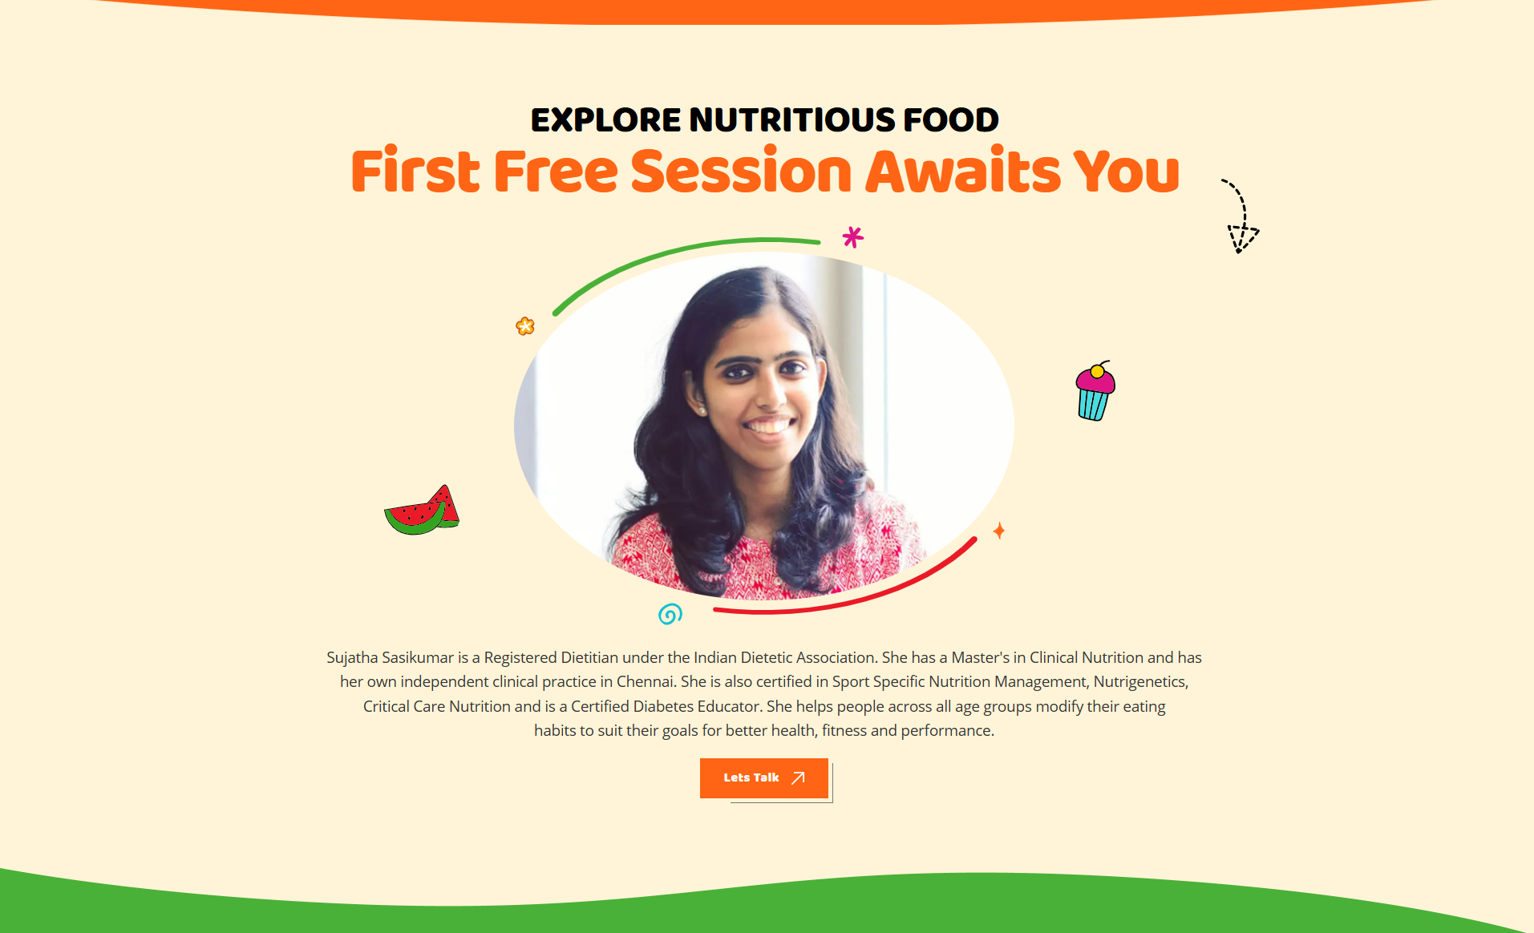

Page Name: Home
Section: Explore Nutritious food First free session awaits you
Section Number: 07
Description: The Nutrition Communication Form (Let's Talk) is designed to facilitate effective communication between users seeking nutrition-related advice or information and the nutrition professionals or client team managing nutrition services.

Form Fields & Validation Rules
- Full Name
  - Input type: Text
  - Validation: Accept only alphabets (A-Z, a-z); spaces allowed.
  - Mandatory field.
- Mobile Number
  - Input type: Number or Text
  - Validation: Must be exactly 10 digits.
  - Must start with 6, 7, 8, or 9.
  - Mandatory field.
- Email ID
  - Input type: Email
  - Validation: Must follow standard email format (e.g., abc@domain.com).
  - Mandatory field.

- Message
  - Input type: Textarea
  - Optional or mandatory based on business needs.

Form Submission Behavior
- When the user clicks Submit:
  - All fields are validated as per the above rules.
  - If validation passes:
    - User details (full name, mobile number, email, and message) are sent to the client and the designated nutrition team/user via the appropriate communication channel (e.g., email or database entry).
    - The user receives an automatic thank you email with the message: "Thank you for the message."
  - If validation fails:
    - The user receives clear, field-specific error messages for correction.

Additional Notes
- Validation should be implemented both client-side (JavaScript/HTML5 validation) and server-side for security.
- The email sending service should ensure delivery of the thank you email promptly.
- The form should be responsive and accessible.
- Privacy of submitted data must be ensured according to applicable regulations.

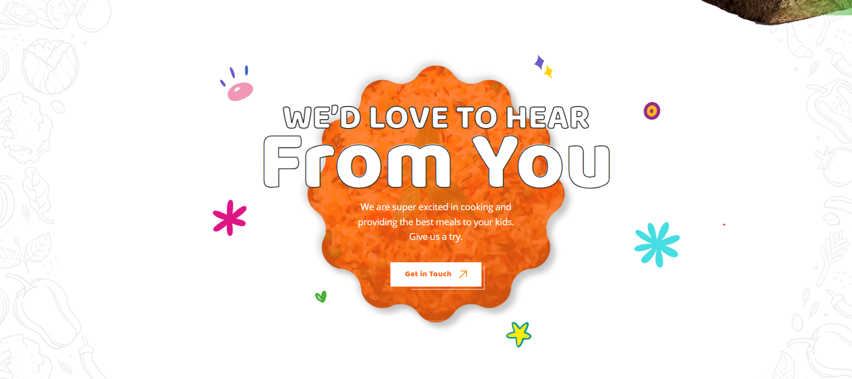

Page Name: Home
Section: We’d Love to Hear From You
Section Number: 09
Description: The “We’d love to hear from you” section on the Home Page is designed to help users communicate with the client. This section encourages visitors to reach out, ask questions, or make service enquiries.
Within this section, there is a “Get in Touch” button. When the user clicks on this button, a form titled “Reach out—we deliver excellence!” opens up.

Overview
This section encourages users (parents/guardians) to communicate with the client for enquiries, support, or feedback. It consists of a “Get in Touch” button that opens a contact form. Once filled and submitted, the details are shared with the client, and the user receives confirmation.

User Flow

Step 1 – Section Display
- Section Heading: “We’d Love to Hear From You”
- Subtext: Messaging to show enthusiasm about cooking and delivering meals to kids.
- Button Displayed: Get in Touch

Step 2 – Form Launch
- On clicking “Get in Touch”, a form titled:
“Reach out—we deliver excellence!” opens.

Step 3 – Form Fields
The form contains 4 fields with validation rules:
- Full Name
  - The user must enter their complete name.
  - Mandatory field.
- Mobile Number
  - Must contain 10 digits only.
  - Should begin with 6 / 7 / 8 / 9.
  - Mandatory field.
- Email ID
  - Must follow proper email format validation.
  - Mandatory field.
- Message
  - Optional text area.
  - The user may type remarks / enquiry / feedback.

Step 4 – Submission
- Validation Check before submission:
  - Full Name not empty
  - Mobile numbers are only 10 digits, starting with 6–9
  - Email format valid
- If validation passes, the form can be submitted.
- If validation fails, show validation error messages.

Step 5 – Post Submission
- Frontend Action
  - The “Thank You” popup/message is displayed immediately on the site.
- Email Notifications
  - User Side: A "Thank You" email confirming receipt of their enquiry is sent.
  - Client Side: The form details (full name, mobile, email, and message) are emailed to the client’s official email ID.
- Client Action
  - Client receives details → Reviews → Contacts the user back through provided contact details.

Validation Rules
- Full Name → Cannot be blank.
- Mobile Number → 10 digits, starts with.
- Email ID → Valid format only.
- Message Field → Optional.

Expected Output
- User fills details → Validates successfully → Submits form.
- The user sees the "Thank You" message on the screen.
- The user receives a confirmation email.
- The client receives enquiry details instantly via email.
- The client can follow up with the user through mobile/email.

Summary
This section provides a smooth Enquiry/feedback experience:
- Easy access through the Get in Touch button.
- Clean and validated form for accurate data capture.
- Dual confirmation (thank you popup + thank you mail) ensures customer trust.
- The client gets immediate notification to quickly respond to user needs.

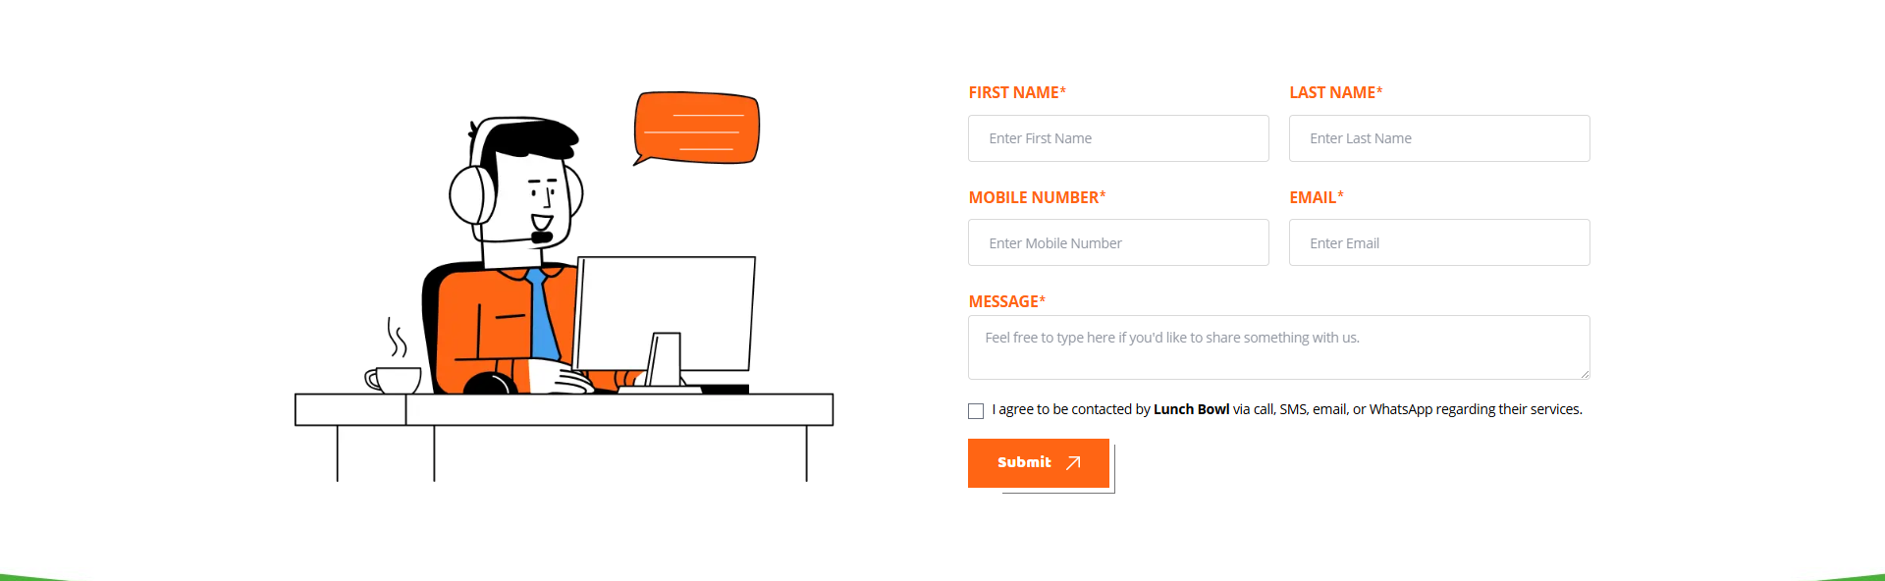

Page Name: Contact Us
Section: Form
Section Number: 03
Description: The Contact Us page is designed to allow users to easily communicate with the client, get information about available plans, clarify any service details, or share additional queries. Through this page, users can submit their details via a simple form, after which the client team will reach out to them.

Purpose
The Contact Us page allows users (parents/customers) to:
- Communicate directly with the client regarding plans, services, and other queries.
- Share their details through a structured form.
- Give consent to be contacted by the client across multiple channels (call, SMS, email, WhatsApp).

Form Fields & Validations
- First Name
  - Input: Free text field.
  - Validation: Cannot be empty. Only alphabets are allowed.
- Last Name
  - Input: Free text field.
  - Purpose: To capture last name/father’s name/husband’s name/initials.
  - Validation: Cannot be empty. Only alphabets are allowed.
- Mobile Number
  - Input: 10-digit numeric field.
  - Validation:
    - Only 10 digits allowed.
    - Must start with 6, 7, 8, or 9.
- Email ID
  - Input: Email text field.
  - Validation: Must follow proper format (e.g., user@example.com).
- Message/Remarks (Optional)
  - Input: Free text field.
  - Validation: Optional, no restrictions.

Consent Checkbox
- Label:
“I agree to be contacted by Lunch Bowl via call, SMS, email, or WhatsApp regarding their services.”
- Functionality:
  - Must be selected before submitting the form.
  - If checkbox is not selected → Show error popup/message “Please agree to be contacted to submit the form.”

Submit Action Flow
- The user fills in all required details and selects the confirmation checkbox.
- When clicking Submit:
  - Frontend validation checks all rules.
  - If valid, the form data is sent to the server and client email inbox.
- After successful submission:
  - The user is redirected to a “Thank You” page/acknowledgment screen.
  - The user also receives a “Thank You” confirmation email.
  - The email includes a greeting, confirmation of query submission, and a note saying the client will contact them soon.

Client-Side Notification
- The client receives an email notification with the details shared by the user:
  - First Name
  - Last Name
  - Mobile Number
  - Email ID
  - Message (if provided)
The client can then reach out to the user on the provided contact details.

Validation Rules – Summary
- First Name: Mandatory, alphabets only.
- Last Name: Mandatory, alphabets only.
- Mobile Number: 10-digit, must start with 6/7/8/9.
- Email ID: Must be a valid format.
- Message: Optional.
- Consent Checkbox: Mandatory → Without selecting, form cannot be submitted.

Expected Outcome
- A smooth communication channel was established between the user and the client.
- User: Receives immediate confirmation (Thank You page + Email).
- Client: Gets direct lead via email and can follow up manually via call/SMS/email/WhatsApp.

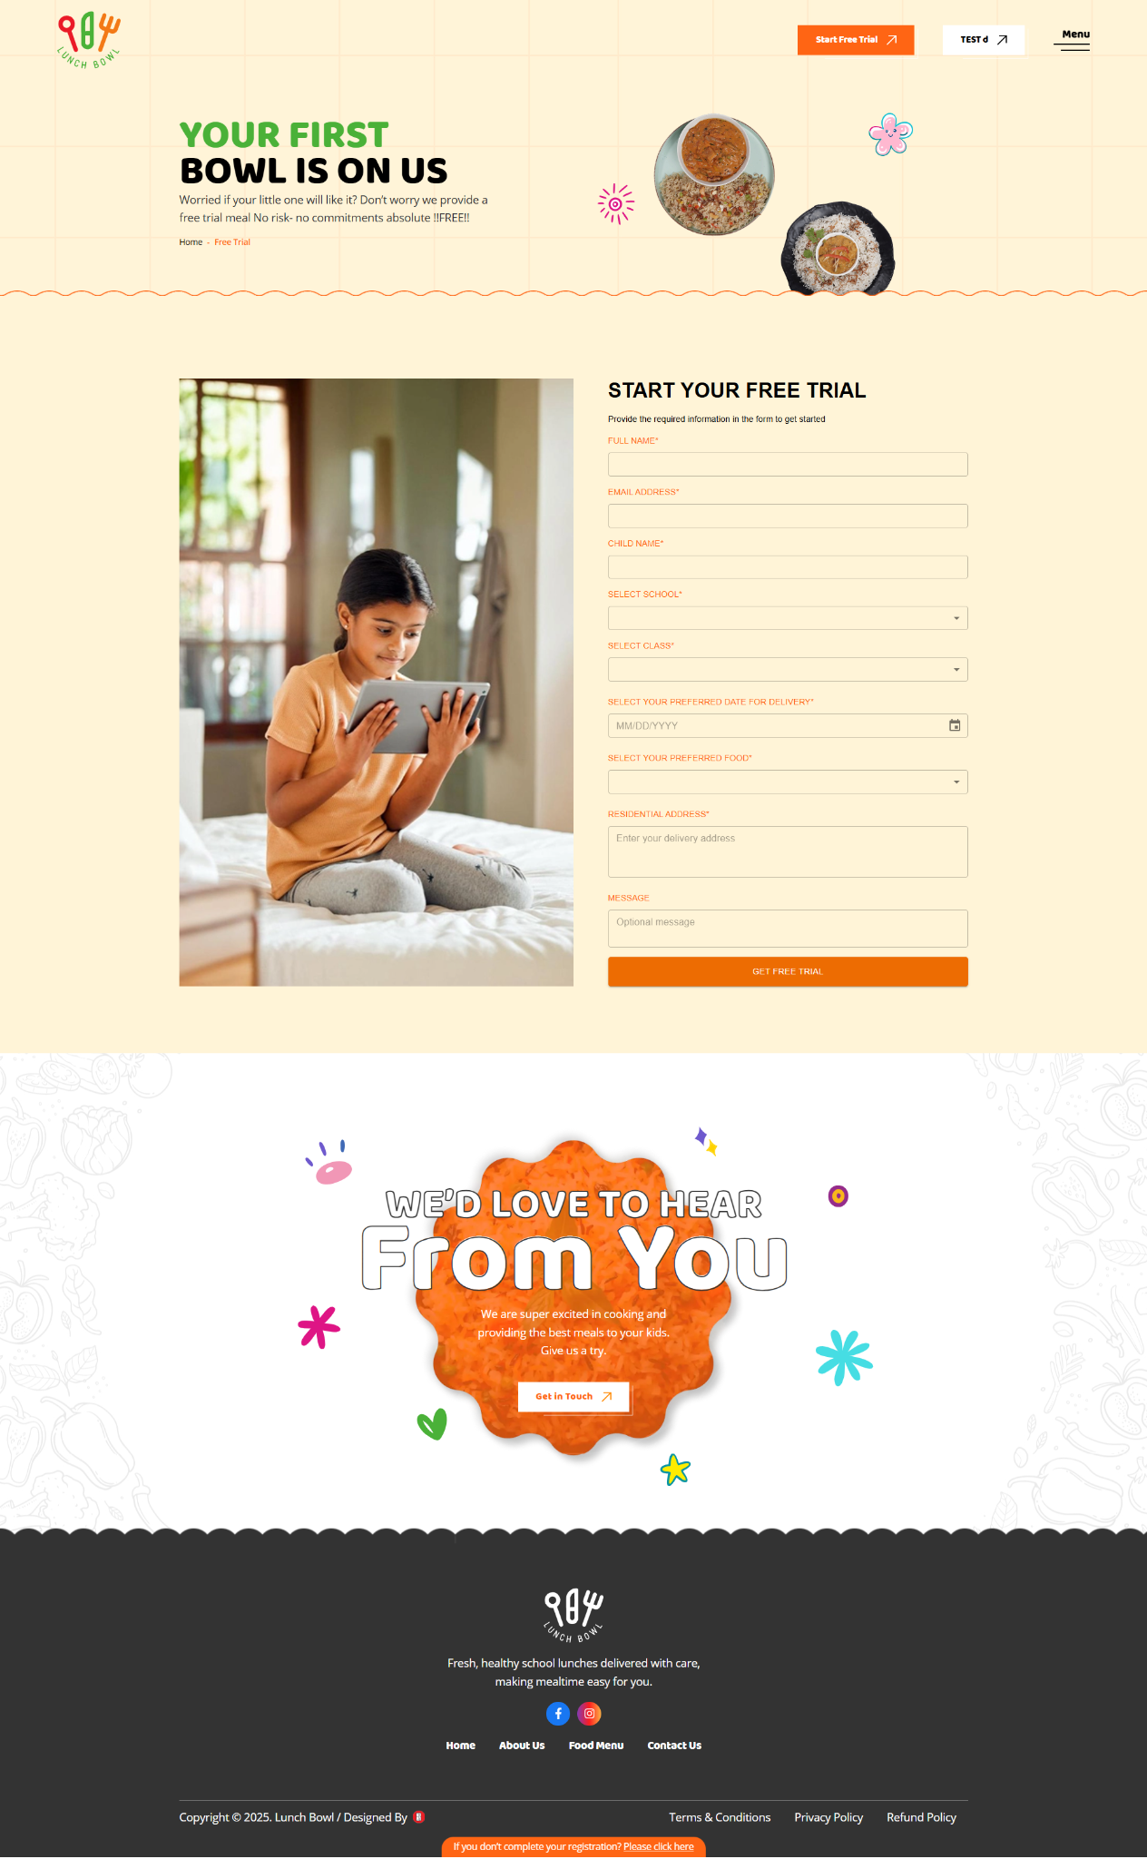

Page Name: All page
Section: Header -Button (Free Trial)

Description: The Lunch Bowl website’s Free Trial process is designed as a gated, user-validated onboarding, ensuring both eligibility and secure signup for parents whose children attend partner schools. Here’s a thorough description content that suits this workflow, describing the user journey and key validation points at each step.

Feature Overview
The Free Trial button is displayed on all pages for new users. Once a user avails the free trial or completes a paid plan selection, the button is hidden for that user on every page .

Workflow Details

Free Trial Button Logic
- Visibility:
  - Shown to all new users everywhere.
  - Hidden if the user has already availed a free trial or paid for any plan.

Free Trial Popup (Step 1)
- Trigger: Clicking the Free Trial button when visible.
- Content:
  - Provides free trial details.
  - Dropdown listing client-associated schools .
- Action:
  - The user must select the school where their child studies.
  - The next button is enabled only after a school is selected.

Signup Popup (Step 2)
- Appears if the selected school is in the client school tie-up list.
- Fields & Validations:
  - Parent First Name: Alphabets only.
  - Parent Last Name: Alphabets only.
  - Mobile Number:
    - Numbers only.
    - Exactly 10 digits.
    - Must start with 6, 7, 8, or 9.
  - Email ID: Must be a valid format.
  - OTP Verification:
    - Send OTP to the entered mobile number on button click.
    - On entering a valid OTP and clicking “Verify OTP,” verify and navigate to the free trial page.
    - If already signed up, immediately navigate to the free trial page.

Free Trial Page (Step 3)
- Pre-populated Fields:
  - School: Selected school from first popup.
  - Parent First Name: Data from signup.
  - Parent Last Name: Data from signup.
  - Mobile Number: Data from signup.
  - Alternative Mobile Number:
    - Numbers only.
    - Exactly 10 digits.
    - Must start with 6, 7, 8, or 9.
  - Email ID: Data from signup.
  - Children's Full Name: Alphabets only.
  - Children's Class: Dropdown, LKG to 12th standard.
  - Date Preference:
    - Date picker.
    - Only future dates (minimum 2 days in the future).
    - Sundays hidden.
  - Preferred Food: Dropdown with client-provided food options for free trial.
  - Address:
    - Split into three fields:
      - Door no./Building/Street.
      - Area/City.
      - Pincode.
- All fields are mandatory.
- Checkbox:
"I agree to be contacted by Lunch Bowl via call, SMS, email, or WhatsApp regarding their services."
  - Form submission is only allowed if checked.
- Submit Action:
  - On clicking Submit:
    - Send a confirmation email to the parent/user.
    - Notify the client via email.

SIGN UP:
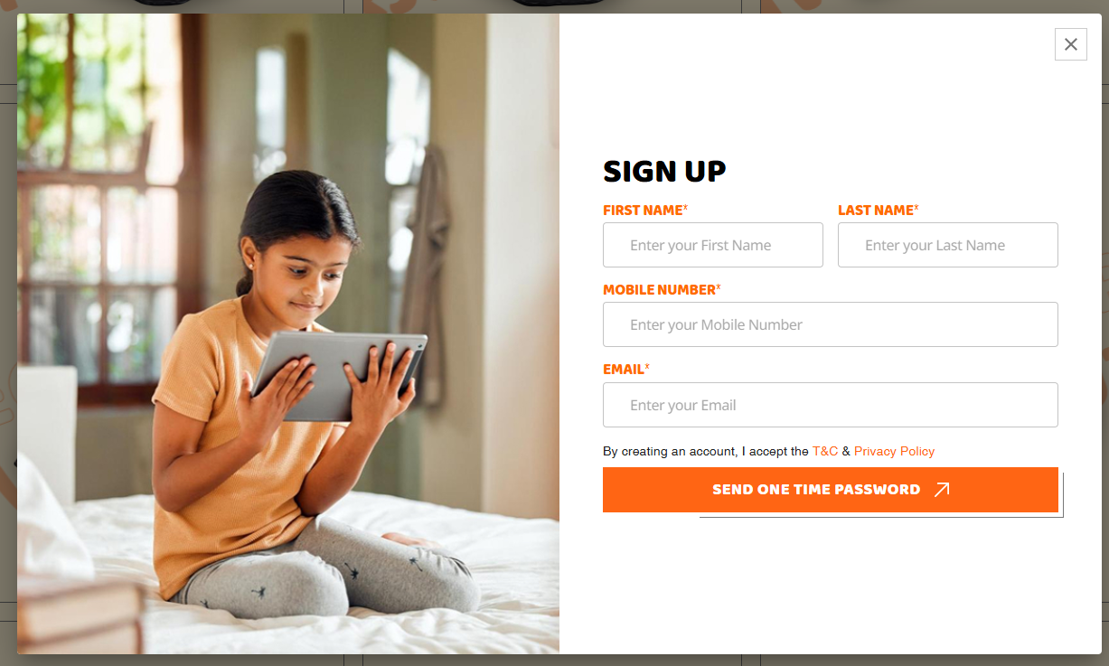
STEPS:
- Open the URL https://lunchbowl.co.in/
- The header displays a login button, which will be used to open a pop-up.
- A subscription is needed before we sign up and finish the 5-step process.
- Sign up form
Entry Point
- User opens https://lunchbowl.co.in/
- Header → Login button
- Popup → Login | Signup
- If already registered → login successful → Dashboard.
- If not registered, → system shows “Create an Account” → redirects to Sign-up form.
Purpose: Start new registration before subscription.

Sign-Up Form
Fields + Validation
- First Name* → Alphabets only
- Last Name* → Alphabets only
- Mobile Number* → 10 digits, starts with 6/7/8/9
- Email* → must contain @ + valid format
- Agreement Checkbox* → must check T&C, Privacy Policy, Refund Policy
-> Button: SEND ONE-TIME PASSWORD
Purpose: Capture base user identity and compliance.
OTP FLOW:

OTP Verification
- User enters 4-digit OTP (numbers only)
- OTP valid for 10 min
- Expired → “OTP expired, please resend”
- Incorrect → “Invalid OTP, try again”
- Correct → moves to Parent Details
Purpose: Verify phone number via SMS before profile creation.

Step 1 – Parent Details
Fields + Validation
- Father First/Last Name* → Alphabets only
- Mother First/Last Name* → Alphabets only
- Mobile Number* → 10 digits, starts 6/7/8/9
- Email ID* → valid format
- Alternative Contact → (future option)
- Pincode* → 6 digits only
- City, State, Country* → Alphabets only
- Residential Address* → Mandatory
-> Button: Next → Child Details
Purpose: Build parent profile for communication, billing & delivery.

Step 2 – Child Details
Fields + Validation
- Child First/Last Name* → Alphabets only
- DOB* → Date picker
- School* → Dropdown (predefined list)
- Location → Auto-populated from school
- Lunch Time* → Dropdown (11AM–12PM / 12PM–1PM)
- Class* → Dropdown (LKG–Grade 12)
- Section* → Dropdown (A–H)
- Allergies → Optional
-> Button: Next → Subscription Plan
-> Button: Back → Parent Details
-> Add Another Child → opens additional child form.
Purpose: Collect each child’s details to customize the meal plan.

Step 3 – Subscription Plan
Rules
- Default: Mon–Sat meals only
- Sunday = CLOSED
- If a Saturday or holiday meal is needed,→ extra ₹200/day.
Options (Radio Buttons)
- 22 Working Days → ₹4,400
- 66 Working Days → ₹12,540 (5% off)
- 132 Working Days → ₹23,760 (10% off)
- Custom Plan → ₹200/day - no offer ( Conditions. The starting date is whatever, but the end date. Last month's date.
Calendar
- Green = working days (Mon–Sat)
- Orange = holidays
- Extra days (holidays/weekends) → bookable, ₹200/day, must request 48 hrs before.
Example Summary
- Start Date: 01 Sep 2025
- End Date: 03 Oct 2025
- Total Days: 22
- Price/Day/Child: ₹200
- Total Price: ₹4,400
-> Button: Next → Payment
-> Button: Back → Child Details
Purpose: Parents select the subscription period and see the billing breakdown.

Step 6 – Payment
Billing Info (Auto-Filled)
- Name, Email, Phone, Address
- Notes (optional)
Timeout: 14 min (session expires if unpaid).
Payment Methods
- UPI (GPay / QR code → EARTH TECH CONCEPTS PRIVATE LIMITED)
- Netbanking
- Debit/Credit Card
- Wallet
- NEFT/RTGS
Coupon Option → discounts if applied
- -> Button: Back → Subscription Plan
-> Button: Next → Payment Gateway
Purpose: Securely complete subscription payment.

Step 7 – Menu Calendar Activation
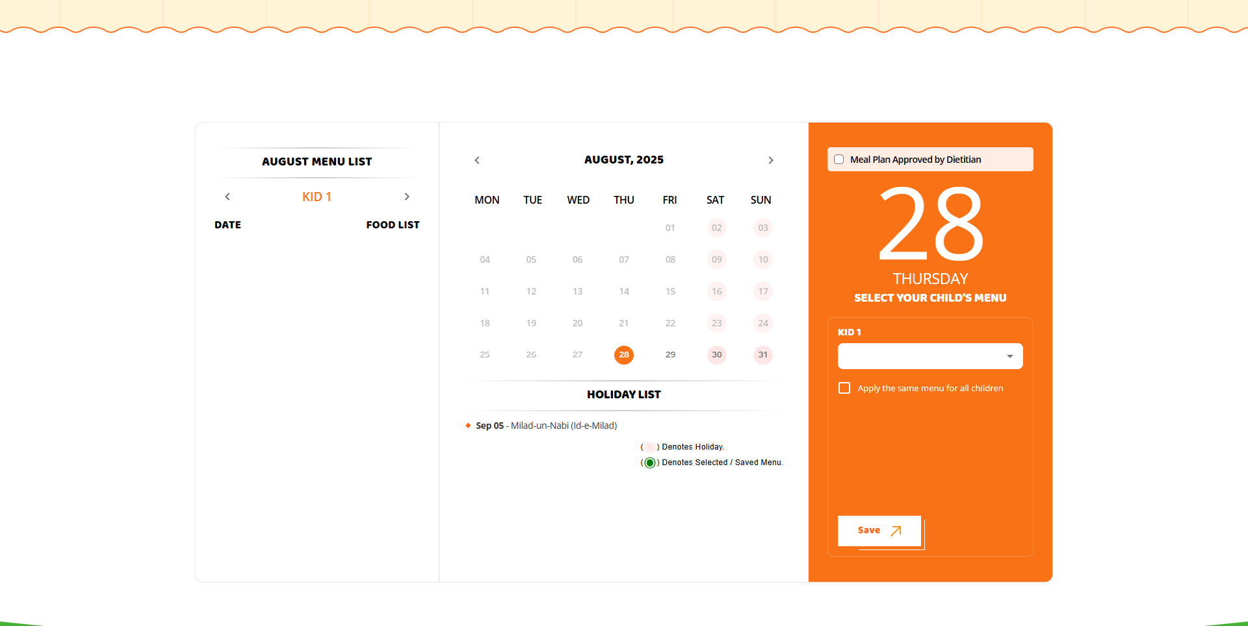
After Payment Success → Redirect to Menu Calendar
UI Layout
- Left: Child list + menu dropdown (5 fixed items) + “Apply same for all children” checkbox
- Center: Calendar →
  - Green = Saved meals
  - Orange = Holidays
  - Locked = past/same-day edits
- Right: Digestive menu list

Rules
- Meals are editable only 48 hrs before the selected day.
- Cancel 48 hrs before → credited to wallet.
- Same-day cancel/edit → Locked.
Purpose: Let parents customize daily meal plans after subscription is active.

Header Dropdown → My Account
When the user clicks My Account in the header:
- DASHBOARD → Shows overview (orders, subscription status, etc.).
- MENU CALENDAR → Default landing after login. Weekly/monthly view of available meals. The user can select meals here.
- MY PROFILE → User details (name, phone, address, child details, subscription info). Editable with validations.
- LOGOUT → Ends the session, user redirected to home page/login page.
-> So, in flow:
- After being already registered, the user goes to the Menu Calendar (default).
- From Header → My Account dropdown, they can navigate between Dashboard, Menu Calendar, and Profile, and Logout.

******************************************************************************************

Testing Report - Bug Sheet
FINAL BUG SHEET:
https://docs.google.com/spreadsheets/d/1lFXuW3LOKRZdEsCPm4QAtrnKLUSGqnBuAlZ2gA_﻿﻿﻿﻿﻿﻿﻿﻿﻿﻿﻿﻿﻿﻿﻿﻿﻿﻿﻿﻿﻿﻿﻿﻿﻿﻿﻿﻿﻿﻿﻿﻿﻿﻿﻿﻿﻿﻿

https://docs.google.com/document/d/1GJ3kPDeMKwXuYOHwLL7hG_o4rIs-bbviZn_1H8fE2H4/edit?tab=t.0

https://docs.google.com/document/d/1xUNATDHkNYsYKhY6QqNTuakVEd3rmJZ5KM_zptMAC_4/edit?tab=t.0

Mail Template
Sign up :

User Mail Template :
Subject : Welcome to Lunch Bowl—You're All Set!

Body Content :
Hi {ParentName},
Your Lunch Bowl account has been successfully created. You can now explore wholesome meals for your child delivered right to their school.

We’re happy to have you with us!
–Team Lunch Bowl and Earth Tech Concepts Pvt Ltd –

Client Mail Template :
Subject: YOURS freshness, wholesome—Welcome to Lunch Bowl

Body of Content:

Parent Name:

Phone Number:

Email ID:

*******************************************************************************

Free trial:

User Template:
Subject: ONE BOWL, ENDLESS FRESHNESS—FREE TRAIL INSIDE

Body of content:
Dear [user name],
Thank you for enquiring about our Lunch bowl FREE TRIAL
We believe lunch should be fresh, wholesome, and hassle-free—and now you’ll get to experience it yourself free on your first bowl with us.
Warm regards,
–Team Lunch Bowl and Earth Tech Concepts Pvt Ltd –
[Button: Confirm My Free Trial]

Client Mail Template :

Subject: New Free Trial Enquiry Received.
Body content:
School Name:
Name:
Email ID:
Mobile Number:
Alternative Mobile Number:
Dish:
Address:
Message:

*******************************************************************************

Let’s Talk

User Mail Template
Subject: Thank you, your message is safe with us—!STAY TUNED!

Body of content:

Dear [user name],
Thank you for getting in touch with us through our Let’s Talk page. We’ve received your message, and our team will review it shortly.
In the meantime, feel free to explore more about us on [website link] or reply to this email if you’d like to share additional details.
We look forward to speaking with you soon!
Best regards,
The Lunch Bowl Team

Client Mail Template
Subject: Let’s talk the NEXT STEP together.
Body of content:
User Name:
Phone Number:
Email Address:

*******************************************************************************

Get In Touch

User Mail Template :
Subject: Thank you reaching out — will be in touch soon
Body of content:
Dear [user name],
Thank you for getting in touch with us! We’ve received your message, and our team is already on it. One of our representatives will connect with you within [X hours/1 business day] to assist with your query.
In the meantime, feel free to explore more about us on [website link] or simply reply to this email if you’d like to share more details.
We look forward to helping you!
Warm regards,
–Team Lunch Bowl and Earth Tech Concepts Pvt Ltd –

Client Mail Template

Subject: New General Enquiry Received
Full Name:
Phone Number:
Email Address:
Message:

*******************************************************************************
Registration + Payment Success Mail

User Template:

Subject: Registration & Payment Successful—Welcome Aboard!

Body Content:
Hi {ParentName},
Your Lunch Bowl registration is complete, and w e've received your payment of ₹{Amount}.
Meal service starts on: {Start Date} - {End Date}
School Name : {SchoolName}
Child: {ChildName}
We’re thrilled to be part of your child’s lunch journey!
For any help, reach out to contactus@lunchbowl.co.in
–Team Lunch Bowl and Earth Tech Concepts Pvt Ltd –
Client Mail Template - Pending

*******************************************************************************

Subscription Renewal Reminder Mail
User Mail Template:

Subject: Renewal Reminder – Keep the Lunches Coming!

Body Content:
Hi {ParentName},
Your Lunch Bowl subscription is due to expire on {End Date}.
To ensure {Child Name} continues receiving their favorite healthy meals, kindly renew before the deadline.
[Renew My Subscription Now]
We’re here to keep the lunchbox full and the child smiling!

Best regards,
–Team Lunch Bowl and Earth Tech Concepts Pvt Ltd –

Client Mail Template: Pending

*******************************************************************************
Holiday Payment
User Mail template -

Subject:
Holiday Meal Payment Confirmation – LunchBowl

Body content:
Hi Maniyarasan T,

Your holiday meal payment is successful.

A meal has been booked for 20/9/2025 with menu Coconut Pulav with Crispy Bhindi and Peanut Fry.

We hope your child enjoys their special holiday meal!

For any queries, contact contactus@lunchbowl.co.in

Best regards,
–Team Lunch Bowl and Earth Tech Concepts Pvt Ltd –

Client Mail Template - Pending -

*******************************************************************************

Food Menu Edit

User Mail template - Pending
Client Mail Template - Pending
*******************************************************************************
Contact Us

User Mail template -
USER MAIL TEMPLATE
Subject:
Thank you for your enquiry!

Body content:
Hello test,

Thank you for reaching out to us through our enquiry form. We’ve received your request, and our team will get back to you shortly with the details.

We look forward to assisting you soon.

Best regards,
–Team Lunch Bowl and Earth Tech Concepts Pvt Ltd –

Client Mail Template—

Subject:
New Contact Us Enquiry

Body content:
Contact Us Enquiry Details
Name:
Email:
Mobile:
Message:
==============================================================
E-mail/Notification Message after deleting the meal

User Mail template -

Subject:
Meal Deletion Confirmation – LunchBowl
Hi (Parent’s name),

Your meal is successfully deleted.

(Child’s name)’s meal booked for yy/yy/yyyy with the menu (meal name) has been deleted by you. The meal amount has been credited to your LunchBowl wallet and can be redeemed at any time.

We look forward to making your child enjoy their meal!

For any queries, contact contactus@lunchbowl.co.in

Best regards,
–Team Lunch Bowl and Earth Tech Concepts Pvt Ltd –

Client Mail Template—

Subject:
New Meal Deletion Alert

Body content:
Meal Deletion Details
Name: (Parent’s Name)
Child’s name:
Email:
Mobile:
Message:

Parent name:
Child Name:
Class/Section:
Date:
Meal name:
School name:

Clent Changes & Updates

# | Date | Sheet Link | Points | Status
1 | 25/08/2025 | https://docs.google.com/document/d/14agPcAXrZnSHxaF1aZDdCxisqAtf55AyVeYbxk0lYOA/edit?tab=t.0 | Featues : 4  Bugs : 3  Changes: 4  Total : 10 | 5 points completed  5 points in progress

Add Child & Renewal subscription

Add Children:

Overview
This documentation explains the workflow for child registration, plan continuation, and meal selection within the Lunch Bowl application. It covers dashboard behavior, registration limits, navigation after payment, and child profile management.

Dashboard Page
- After successful sign-up, users are navigated to the Dashboard.
- On the Dashboard, under the Register Children tab:
  - An Add Children button is visible only if there are fewer than 3 registered children.
  - If 3 children are already registered, the button will not be shown.
- When the Add Children button is clicked:
  - The user is navigated to the Children Details entry page.

Children Details Page
- The page displays a summary section showing:
  - A detailed list of already registered children.
  - An option to "Add Other Children":
    - If 1 child is already registered → up to 2 more can be added.
    - If 2 children are registered → only 1 more can be added.
    - Maximum allowed = 3 children.
- After entering new child details:
  - A Next button becomes visible.
  - On clicking Next, the user is redirected to the Payment Page.

Payment Page
- The payment page allows users to complete the transaction for the newly added child/children.
- Once payment is completed:
  - The user is navigated to the Menu Calendar Page.

Menu Calendar Page
- Displays daily meal options where users can:
  - Choose meals per day.
  - Save their selections.
- For newly added children:
  - Their meal plan will be in continuation with the already active plan.
  - The plan for new children will activate only after 48 hours of successful payment.
  - After activation, meal delivery begins as per saved preferences.

Profile and Dashboard Updates
- Both My Profile page and Dashboard will display:
  - Newly added children alongside previously registered children.
- Status of each child’s plan is shown (active or pending activation).
========================================================================
Renewal Subscription

Overview
This documentation covers the subscription renewal feature and transaction history management within the Lunch Bowl application. It explains how the renewal button works, child management during renewal, subscription selection, payment flow, and history tracking.

Dashboard – Renewal Subscription Button
- A Renewal Subscription button is available on the Dashboard.
- Button behavior:
  - Disabled: Until the active plan has more than 10 days remaining.
  - Enabled: Exactly 10 days before the active plan’s expiry date.
- When the button becomes enabled:
  - An automated reminder email is sent to the user informing them about upcoming plan renewal.
- Clicking the Renewal Subscription button:
  - Navigates the user to the Child Details Page.

Child Details Page (During Renewal)
- Displays list of all registered children.
- User options during renewal:
  - Add new children
  - Remove existing children.
- After editing child details:
  - Clicking Next navigates to the Subscription Plan Page.

Subscription Plan Page
- User can view and select available subscription plans.
- Plan chosen will be applied to the children selected in the previous step.
- After plan selection:
  - Clicking Next navigates to the Payment Page.

Payment Page
- User makes payment for the selected plan(s).
- Once payment is successfully completed:
  - User is redirected to the Menu Calendar Page.

Menu Calendar Page
- User can:
  - Choose meals on a per-day basis.
  - Save preferences.
- Renewed plan will continue seamlessly from the expiry date of the previous plan without service interruption.

Transaction History Page
- A separate Transaction page displays Payment History.
- For each transaction, the following details are shown:
  - Transaction ID
  - Child(ren) covered under payment
  - Plan type selected
  - Payment date and time
  - Payment status (Success/Failed/Pending)
  - Amount paid
- This page acts as a full historical record of all past and current payments.

(04/10) Renewal Subscription & History

Lunch Bowl - Renewal Subscription Feature Documentation

Overview
The dashboard includes a "Renewal Subscription" button that becomes enabled 10 days before the currently active plan expires. Until then, the button was hidden. When enabled, a reminder email is sent automatically to the user.

Workflow and Functionality

1. Renewal Button Activation
- The renewal button is hidden until the active subscription plan is within 10 days of completion.
- Upon becoming enabled, the system sends a reminder email to the user indicating that renewal is available.

2. Child Details Page Navigation
- Clicking the renewal button navigates the user to the child details page.
- On this page, the user can add new children or review existing child details.
- After adding or verifying child details, the user clicks "Next" to proceed.

3. Subscription Plan Selection
- The user is directed to the subscription plan section, where the list of available plans is displayed.
- Above the plan, the list combines newly added children and existing children, each with a checkbox.
- The user selects checkboxes corresponding to the children for whom the renewal plan should be activated.
- Only the children selected will have the renewal plan applied.

4. Plan Confirmation and Verification
- After selecting the children, the user chooses the desired subscription plan.
- A verification checkbox is presented, which the user must enable before proceeding.
- Clicking "Next" moves the user to the payment section.

5. Payment and Plan Activation
- The user completes payment for the renewal plan.
- Upon successful payment, the new subscription plan is added and activated.

6. Handling Existing Plan States
- If a previous plan is still active at the time of renewal payment, the renewal plan will commence immediately after the current plan ends.
- If the previous plan has expired, the renewal plan will start 48 hours after payment confirmation.

7. Renewal History Tracking
- All renewal activities, including child details, selected plans, payment status, and timestamps, are recorded.
- This information is displayed on the user's history page for transparency and audit.
=======================================================================

Lunch Bowl – View History Feature Documentation

Overview
The dashboard includes a "View History" button that navigates users to the History page displaying a detailed table of all subscription and payment related transactions for transparency and tracking purposes.

History Page Layout
- Table Columns:
  - Transaction ID: Unique identifier generated for each payment or transaction.
  - Plan Type: Describes the type of feature or action the transaction pertains to, such as subscription, renewal, add children, holiday payment, etc.
  - Amount: Shows the amount paid for the selected feature or action.
  - Date & Time: Displays the exact date and time when the transaction or feature action was completed.
  - Payment Status: Shows "Paid" if payment succeeded and "Failed" if it did not.
  - Plan Details: Contains a "View" button for each row to examine detailed information about the transaction.

Plan Details Popup
- Clicking the "View" button opens a popup showing detailed information in labeled sections:
  - Children's Names (for each child involved)
  - Plan Type
  - Start Date
  - End Date
  - Total Days (number of days)
=======================================================================

Add Children:

Overview
This documentation explains the workflow for child registration, plan continuation, and meal selection within the Lunch Bowl application. It covers dashboard behavior, registration limits, navigation after payment, and child profile management.

Dashboard Page
- After successful sign-up, users are navigated to the Dashboard.
- On the Dashboard, under the Register Children tab:
  - An Add Children button is visible only if there are fewer than 3 registered children.
  - If 3 children are already registered, the button will not be shown.
- When the Add Children button is clicked:
  - The user is navigated to the Children Details entry page.

Children Details Page
- The page displays a summary section showing:
  - A detailed list of already registered children.
  - An option to "Add Other Children":
    - If 1 child is already registered → up to 2 more can be added.
    - If 2 children are registered → only 1 more can be added.
    - Maximum allowed = 3 children.
- After entering new child details:
  - A Next button becomes visible.
  - On clicking Next, the user is redirected to the Payment Page.

Payment Page
- The payment page allows users to complete the transaction for the newly added child/children.
- Once payment is completed:
  - The user is navigated to the Menu Calendar Page.

Menu Calendar Page
- Displays daily meal options where users can:
  - Choose meals per day.
  - Save their selections.
- For newly added children:
  - Their meal plan will be in continuation with the already active plan.
  - The plan for new children will activate only after 48 hours of successful payment.
  - After activation, meal delivery begins as per saved preferences.

Profile and Dashboard Updates
- Both my profile page and dashboard will display:
  - Newly added children alongside previously registered children.
- The status of each child’s plan is shown (active or pending activation).
- MANI TESTING - FUNCTIONALITY - PAGES -3 DAYS
- ADDCHILD
- RENEWAL
- TRANSACTION PAGE
- MENU CALENDAR
- SIVA REX
- ADMIN PANEL - 1 DAY
- BUG FIX
- DATABASE MIGRATION
- EXISTING USER MEALS
- SIVA -
- CSS - 4 DAYS

2nd phase
2ND PHASE

- NO MEAL & WALLET
- FAVOURITE MEAL
- UI- FAVORITE MEAL
SIVAREX- 5 DAYS
MANI TESTING - 2 DAYS
BUG FIX- 2 DAYS
NO MEAL & WALLET —
1. MENU CALENDAR PAGE -

APP
LUNCHBOWL APP
BHARATHI -
1. CURRENT WEBSITE FLOW CHECK - 1 DAY
2. TASK ANALYSING AND TIMELINE NEED
3. GATHERING API FROM - SIVAREX

SIVA REX
1. PROVIDE API - 1 DAY
UI -
SUNIL - CURRENT WEBSITE FLOW DESIGN FOR APP - (ANALYZE AND TIMELINE )

2nd Phase Documentation
Design Link: https://www.figma.com/design/pZJPXWqc6WYEBa4cKL8Fer/Lunch-Bowl?node-id=382-888&p=f&t=SgvKApQ0cs15gwJz-0

Food Menu – Edit & Delete Functionality Documentation

1. Overview

The Menu Calendar page displays a menu list on the left side. Each menu item must show Edit and Delete options.
These options appear based on time restrictions.

2. Edit Option – Rules

The Edit button should be visible only for dates that are at least 48 hours (2 days) ahead of the current date.

For the current day or the next 48 hours, the Edit option must not be shown.

3. Delete Option – Rules

The Delete button should be visible only for dates at least 24 hours ahead.

For the current day, the delete option should be available only until 11:59 PM of the previous night.

For future days, users must delete the meal before 11:59 PM of the day before that meal date.

4. Delete Button – Hover Message

When the user hovers over the Delete button, show a tooltip message like:

“Need Content” : Delete meal permanently

5. Delete Confirmation Popup

When the user clicks the Delete button, a confirmation popup should appear.

Popup Content

Message:
“Need Content”: This action cannot be undone!
Are you sure you want to delete this meal permanently?

Buttons:

- Confirm

- Cancel

Cancel Button Action

- Close the popup.

- Do not delete the meal.

- Keep the food menu for that date unchanged.

Confirm Button Action

- Delete the food menu for the selected date.

- Remove the food name.

- Display the text “Deleted” in place of the food name.

6. After Deleting a Meal

Right-side Child Dropdown Behavior

Instead of the usual child menu selection dropdown, show a tab containing informational text (“Need text Name”). This Meal is deleted. The meal amount is credited to your LunchBowl wallet.
Redirect to my wallet
When the user clicks this text, redirect them to the Wallet Page.

7. E-mail/Notification Message

After successful deletion, send an email to the Client and the user’s registered number, such as:

“Your meal for [Date] has been deleted successfully.”
“Need mail template For User and Client.” : {Content given at mail template section}

8. Wallet Page – Record Handling

When a meal is deleted, store the following details on the Wallet Page:

- Child Name

- Deleted Meal Date

- Food Name

- Food Price

========================================================================

Wallet Page – Functionality Documentation

1. Access Permissions

The Wallet Page should be visible only to users who have created an account and purchased a plan.

After a user purchases a plan:

A “My Account” button becomes enabled.

When the user clicks “My Account,” a submenu appears.

From the submenu, when the user clicks “Wallet,” they should be redirected to the Wallet Page.

2. Wallet Page Layout

The Wallet Page is divided into two sections:

The left side of the page contains:

A mini wallet tab that displays the user’s total wallet points.

Below Section – Wallet Summary

A “How It Works” section that explains how the wallet points system operates.
“Needed content”
- Points are added to your wallet when you cancel a meal.
- 1 point = 1 Rupee
- Saved points can be redeemed in your next subscription.
- Points cannot be transferred or exchanged for cash.

Wallet Points Calculation

Wallet points are earned when the user deletes a meal for a specific day from their plan.

Each deleted meal's price/value should be added as wallet points.

Example:
If a user deletes a meal for a day, the cost of that meal should automatically be added to the user’s wallet as points.

If multiple days/meals are deleted, the points should accumulate based on the total cost of all deleted meals.

3. Right Section – Points History Table

The right side of the page contains a “Points History” table.

Table Fields

The table should have four columns:

1. Date - The date on which the meal was deleted.

2. Child Name - The name of the child associated with the deleted meal.

3. Meal Name - The specific meal that was deleted.

4. Points - The price of the deleted meal, which is added as wallet points.

Each record represents one deleted meal and the corresponding points earned.

4. Additional Notes

The wallet points are based purely on meal deletions after a plan is purchased.

Points must update instantly when a meal is deleted.

The wallet summary should always show the current total available points.

The Points History table should be sortable or display entries in reverse chronological order.

========================================================================

Wallet Points Redemption – Functionality Documentation

Overview

The Wallet Points Redemption feature allows users to redeem their wallet points only during subscription plan renewal. The option to redeem points will appear only if the user has available wallet points.

1. Navigation Flow

1. On the Dashboard, when the user clicks the Renew Subscription button, they are redirected to the Child Details page.
2. From this page, the user navigates to the Subscription Plan Selection section.
3. The user selects the child for whom the subscription is being renewed.
4. After selecting the child, the user chooses a subscription plan.

2. Wallet Points Redemption Visibility

If the user has no wallet points, the redemption checkbox will not be shown.
If the user has wallet points, a checkbox will appear with wallet points redemption information:
“Need content”: Note: Wallet points applied will automatically reduce your final payable amount
When the user clicks the checkbox, a detailed table must expand.

3. Wallet Points Redemption Details Table

When the checkbox is selected, a table opens containing the following rows:

Row 1 – No. of Children
Label: “No. of Children”
Displays the number of children for whom the plan is being renewed.

Row 2 – Plan Days / Price
Displays the subscription duration (in days) and the original price.
The original price should appear struck-through.
The offer price should be shown clearly.

Row 3 – Redeemed Points
Label: “Redeemed Points”
Displays the number of points the user is redeeming for this renewal.

Row 4 – To Pay
Label: “To Pay”
Shows the final payable amount after subtracting the redeemed points from the offer price.

4. View Details (Redeem Calculation Popup)

Below the table, a text link “View Details” will be displayed.
When the user clicks this text, a popup should open.
The popup will contain the following content: “Need content”: Note: If your wallet points exceed the subscription amount, only 80% of the wallet value will be applied. The remaining points will be available in the wallet and can be redeemed during the next subscription. This popup explains how the redeem calculation works.

5. Saved Amount

Outside the table, a label “Saved” will be displayed.
This value shows the total amount saved,Plan Offer discount

6. Wallet Update After Payment

After the payment is completed:
The redeemed points are deducted from the user's wallet.
The updated remaining wallet balance is displayed in the Wallet → Points tab.

